ISLAMIC REPUBLIC OF MAURITANIA

MINISTRY OF HEALTH

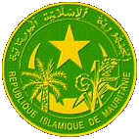

BASIC HEALTH SERVICES AND NUTRITION DIVISION

EXPANDED PROGRAM ON IMMUNISATION

INTRODUCTION PLAN FOR INACTIVATED POLIO VACCINE
IN ROUTINE EPI

May 2014

Summary of the introduction plan

-Justification for the introduction and the strategy to combat polio

The many efforts made in Mauritania to combat polio enabled the country to support its documentation to certify the eradication of polio in 2007 on the occasion of the 9th general annual review of the Regional Commission for the Certification of Polio Eradication for Africa (CRCA) held in Brazzaville from 8 to 10 October 2007 and was accepted. From that time on, the Islamic Republic of Mauritania was declared "disease free." However, 2 years thereafter, the country experienced a reimportation of cases of type 1 wild poliovirus. In total, 18 cases of wild poliovirus were identified during the time period from 27 October 2009 to 28 April 2010 (13 cases in 2009 and 5 cases in 2010). These cases were spread out over the whole territory of the country. All areas of the country were affected, even the least populated ones, and those that at the outset appeared to be at low risk. In order to deal with this situation, several national immunisation campaigns were organized (2 in 2009, 8 in 2010, 5 in 2011 and 3 in 2012 and 2 in 2013).

The improving economic situation in Mauritania enabled its economy to be diversified throughout the year 2011 with the consolidation and revitalization in 2012 of financial cooperation with emerging countries and other partners including GAVI, The World Bank, etc. This was an opportunity to introduce new vaccines in order to achieve objective number 4 of the MDGs, namely that of reducing infant mortality, more quickly. Thus in accordance with the strategic framework to combat poverty, the national health policy 2006-2015, the National Health Development Plan (PNDS), the new Global Immunisation Vision and Strategy (GIVS) and in the continuation of the EPI strategic plan 2001-2010, a comprehensive Multi-Year Plan (cMYP) was developed then revised, covering the period 2011-2015. This cMYP plans for the introduction of new vaccines in the routine immunisation programme, in particular the vaccine against pneumococcal infections (PCV13) that was submitted, approved and implemented beginning in November 2013. The vaccine against rotavirus infections and the one for meningitis to be introduced in 2014; the application for the introduction of other new vaccines, in particular the yellow fever vaccine and the vaccine for injectable polio in March 2015.

- Outline of the benefits to the population of introducing IPV and the costs to the programme of its introduction and how the country plans to sustain those costs.

The introduction of the IPV in the routine immunisation schedule will bring numerous advantages for the country. In this case, these would be reduced risk of emergence of outbreaks of cVDPV, as well as the risks associated with withdrawing OPV2 including the reappearance of type 2 poliovirus, maintaining the status of a polio-free country considering the effect of the IPV vaccine in strengthening immunity against type 1 and 3 poliovirus in children already having been immunised with the OPV. All of this will contribute to the effort to accelerate the eradication of polio worldwide.

The IPV introduction programme costs will be supported by the State, GAVI and other partners: WHO, UNICEF. The funds for the introduction of the IPV that will be granted by GAVI will contribute in large part to managing implementation activities related to the introduction of this vaccine (preparation, operational costs, assessment, etc.)
The inactivated polio vaccine (IPV) will be introduced at the national level in March 2015 and will be administered in contact with DTP-HepB-Hib3 and PCV 13-3 intramuscularly at the deltoid area of the left arm.

- Introduction method with schedule: Overview of how the vaccine will be introduced (national or phased introduction) and review of key milestones and activities (introduction schedule for the vaccine and when preparatory activities begin, for example).
The Inactivated Polio Virus (IPV) will be introduced on a national scale starting in March 2015. As soon as the country's application is approved by GAVI, preparatory activities will be launched, among these: the review of EPI tools and the production of training modules and communication materials, cascaded training for providers and awareness-raising of networks responsible for public relations and social mobilization (NGOs, journalists, etc.) and making the vaccine available to healthcare facilities before the launch.
- Overview of the capacity of the immunisation programme to introduce the IPV, including all aspects of supply chain and logistics, health workforce capacity, etc.
Lessons learned from the experience of previous new vaccine introductions, and in particular the pneumococcal vaccine (PCV 13) in 2013, will be used to facilitate the introduction of the IPV. A steering committee has been established at the Central level in order to coordinate planning, preparation and implementation of introduction-related activities. Thus:

The technical sub-committee supervised the briefing of field workers, developed the introduction plan and is responsible for the on-time submission to GAVI of the support application for the IPV. It is responsible for developing training materials, management tools and the implementation of a training plan for all of the players.
The social Mobilization sub-committee develops the communication plan and monitors the implementation of communication strategies as well as the production of IEC materials and the organization of the official launch of the IPV in March 2015.

According to the Logistics sub-committee, the positive storage capacities available at the central level enable all the quantities necessary for the current operation of the programme to be stored. However, it is preferable to strengthen the storage capacity of the central and regional level cold chain for the introduction of upcoming vaccines. Thus, a 40m3 positive cold room is planned to cover central warehouse cold chain requirements for the next five years and new refrigerators and freezers are in the process of being acquired. At the operational level, the problem of storage capacity is not an issue. This sub-committee will work with the National Regulation Authority (ANR) on the approval procedure for the IPV and will order the IPV vaccines through UNICEF. It will ensure the IPV vaccines are made available at the operational level.

The Monitoring and Evaluation sub-committee monitors all of the stages of planning and implementation. It will be responsible for implementing the supervision plan (before, during and after the launch of the IPV), for surveillance of AEFI cases, and for analyzing data transmitted regarding the doses of IPV administered. It will also coordinate the post-introduction assessment of the IPV. This same model of coordination is identified at the level of health Regions and Districts.
.
Civil society is also involved in the IPV introduction process, for it makes up the interface between the health system and the community through the networks of NGOs and journalist associations. In particular, its role is built around communication, social mobilization, supervision and monitoring-evaluation of activities within the community (traditional and religious leaders, community workers, etc.).

The country's political will, shown by taking ownership of the strategic plan for the eradication of polio and the final phase 2013-2018, is one of the opportunities to ensure introduction of the IPV under the best conditions.
- Summary of preparatory activities completed or to be undertaken.
The Minister approved the decision to introduce the IPV and ordered the implementation of preparatory activities with a timeline shared with the partners.
To this end, a multidisciplinary group will be set up as soon as the application has been approved to run through all of the preparatory activities chosen in the attached timeline.

- Brief description of main risks/challenges associated with the introduction of IPV and outline of the mitigating strategies put into place to address these risks (or meet these challenges).
The only risks/challenges raised for this introduction is the parents' concern about one additional injection at the same time. Keeping the immunisation card and record in order to identify the immunised children remains a major challenge
Training providers and communication networks on the importance of this additional dose , as well as awareness-raising in the communities will allow this challenge to be met.
This document covers the following areas:

1. Justification of the introduction of the IPV and national decision-making process
2. General description of the IPV
3. Considerations related to the introduction and implementation
4. Situational analysis of the immunisation program
5. Monitoring-Evaluation
6. Advocacy, public relations and social mobilization

- Justification of the introduction of the IPV and national decision-making process

In May 2013, the World Health Assembly adopted the new Strategic Plan for the eradication of polio and the final phase (End game) 2013-2018. In addition to intensifying the actions aiming to stop polio in still-infected countries, the strategic plan calls on all of the countries to strengthen their routine immunisation programmes and to replace the trivalent oral polio vaccine (tOPV) with the bivalent oral polio vaccine (bOPV) by 2016, thus eliminating the cases of polio and epidemic outbreaks due to the the OPV type 2 component.
In order to minimize the risks associated with the withdrawal of the bOPV, the WHO strategic advisory group of experts (SAGE) on immunisation recommended that:
- all countries introduce at least one dose of inactivated polio vaccine (IPV) in their routine immunisation schedule before the end of 2015;
- the dose of IPV be administered starting from the 14th week after birth, at the time DTP3 is administered; and
- the IPV be administered in addition to existing doses of OPV.

The introduction of at least one dose of IPV brings three considerable advantages:
1°) The reduced risk of reemergence of type 2 poliovirus after the withdrawal of OPV2.
2°) Strengthening of immunity against types 1 and 3 poliovirus, which will enable the global vulnerability to still-existing wild polioviruses to be reduced, and also accelerate eradication in infected areas.
3°) Make it easier to interrupt any type 2 epidemic outbreak by guaranteeing a faster and more effective immune response to type 2 monovalent OPV at that precise moment.

In view of the schedule for the final phase, SAGE recommended that national plans be developed to facilitate IPV introduction in endemic countries and those that present a high risk of polio between now and mid-2014, and in countries that currently only use the OPV by the end of 2014.

Demonstrate that the main decision-makers of the organizations concerned (Ministry of Health, Ministry of Finance, etc.) have participated in the discussions about the introduction, taken part in the final decisions regarding the introduction of the IPV and approved it.
The national programme submitted SAGE's recommendation to the Minister of Health's cabinet while suggesting a road map to that end. On the instructions of the Ministry of Health, an initial session of the ICC was held on 17 April 2014 to share this information with all of the members and the final decision was made in the session of 25 April 2014 in the presence of representatives of the Ministry of Economic Affairs and Finance. The minutes of the ICC meetings where the question of the introduction of the IPV was on the agenda are attached.

Describe the involvement of other relevant stakeholders, e.g. Civil Society Organizations, community representatives, national regulatory authorities, academic and training institutions and, as applicable, the private sector, in the decision-making process.
Most of these players are represented in the ICC and for this reason were well informed before taking part in the decision-making process. Attached are the make-up of the ICC and the record of its meetings on this subject.
The briefing of players such as the members of the Polio Committees, the Leaders at the Central and Regional levels, the technical and financial partners followed this step (March 2014). Afterwards, the development process for the introduction plan mobilized several people from programmes and central directorates of the Ministry of Health, representatives from Civil Society and Technical and Financial Partners.

Establish the technical and operational feasibility for the introduction of the IPV, taking into account the experience gained by the country as regards the introduction of other new vaccines.
Mauritania can already capitalize on its experience from the introduction of 3 new vaccines in its immunisation schedule: hep B (2005), Hib (2009), and PCV-13 (2013). Lessons have already been learned on the technical as well as operational side and will used to facilitate the introduction of the IPV and make it successful. Among these, the following can be cited:
- Establish a detailed time line for introduction activities at the regional and district levels.;
- Use the opportunity of pre-introduction trainings to recycle the providers on cold chain and vaccine management in all of the districts.
- Make available to providers specimens of the new vaccine during training.
- Carry out close monitoring after training providers through formative supervision, in order to continue strengthening personnel capacities on the new vaccine;
- Combine mass communication with increased continuous local communication as well as advocacy at all levels;
- Make sure all of the health districts introduce the new vaccine at the same time;
- Strengthen the implementation of the advanced and mobile immunisation strategies in the areas not covered by fixed immunisation sites;
- Strengthen the management of AEFI; Injection safety and data management.

- General description of the IPV

  - Vaccine preferences
Please specify vaccine preferences in Table B1 below.
Given that the vaccine is presented in liquid form, the wastage rate could be limited by applying the multi-dose opened vial policy and given that the 10-dose vial presentation requires less storage capacity, Mauritania plans to introduce the VPI starting in March 2015 with a 10-dose vial presentation of the vaccine as the first option.

Table B1. IPV vaccine preferences and estimated date of introduction
Preferred IPV vaccine | Month and year of first vaccination | Preferred second presentation | Preferred third presentation
10-dose vial  The vaccine format chosen causes a great deal of wastage, | March 2015  the introduction date may be sooner than planned | 5-dose vial | 1 dose vial (not yet approved by the WHO)

2.2 National Approval
Provide information on the status of the NRA in the country, i.e. whether functional and/or WHO-certified.
The country has a functional NRA that fulfills several functions, namely:
- approving products and granting authorizations to put them on the market
- post-commercialization surveillance, including the surveillance of Adverse Events Following Immunisation (AEFI).
- ?

Indicate if national approval will prove necessary for the IPV, in addition to pre-qualification from the WHO; if this is the case, describe the procedure and indicate its duration. Indicate whether the country accepts the WHO's accelerated registration procedure for pre-qualified vaccines.
The approval process is carried out in four stages
- Receipt of files: required documents are verified. Complete applications are retained. Incomplete ones are rejected. In both cases the laboratory involved is notified;
- Expert assessment: carried out by specialized commissions. LANACOME is the specialized expert from the national expert assessment commission;
- Decision: the opinions of the National Commission are presented for the approval of the Minister of Public Health;
- Inspection: post-marketing activities provided by the Inspectorate General for Pharmaceutical and Laboratory Services (IGSPL) and the DPML.
This process usually lasts two to three months, which may be reduced in cases of close monitoring.

Provide the actual licensure status of the preferred presentation and of any alternative presentations.
- Customs clearance and transportation of the vaccine from the airport to the central warehouse are carried out for routine by the government and by the country office of UNICEF in the case of vaccines intended for supplementary activities.
- UNICEF has a two-year agreement starting in March 2014 with a forwarding agent/transporter that picks up vaccines and immunisation materials on its behalf directly upon their arrival at the airport or in the port. Vaccines follow the direct pick-up process immediately upon arrival. Once the products have been picked up, they are delivered to the central EPI.

Describe local customs regulations that are in force, requirements for pre-delivery inspection, special documentation requirements that may potentially cause delays in receiving the vaccine. If delays are expected, indicate the measures that have been taken to remedy them.
In terms of clearing the vaccines and injection supplies for routine immunisation through customs, each year the EPI requests and obtains exemption from custom fees from the Ministry of Finance. However, payment of the IT tax, customs forwarding agent fees and transportation remain the responsibility of the EPI. The latter provides pick-up and transportation of vaccines and injection supplies from the port of entry (port or airport) to the GTC-EPI.

  - Target population and vaccine supply

POPULATION | 2015 | 2016 | 2017 | 2018
Total population | 3 736 052 | 3 839 541 | 3 945 896 | 4 055 198
Live births | 164 386 | 168 940 | 173 619 | 178 429
Deaths | 12 658 | 13 008 | 13 369 | 13 739
Surviving Infants < 1 year | 151 729 | 155 931 | 160 251 | 164 690
IPV coverage | 70% | 90% | 92% | 94%
Target population having received the 1st dose(s) of IPV | 106 210 | 140 338 | 147 431 | 154 808

Mauritania subscribed to the initiative for vaccine independence in 1996, and since that date a budget line item is entered every year for the purchase of vaccines and consumables.
Vaccines are received and stored at the level of the central cold chain, which distributes them.
The country has decided that its vaccine purchases will be made through UNICEF, in accordance with a MOU with UNICEF for refundable purchases. The funds will be paid regularly by the Government into the UNICEF bank account for GAVI as with traditional vaccines in the framework of the Vaccine Independence Initiative (VII).

- GAVI purchases and distributes the vaccines through the intermediary of UNICEF or the PAHO revolving fund. If an alternative mechanism is requested by the country, please document the following:

a description of this mechanism and the vaccines or supplies the country will purchase; and the functions of the national regulatory authority (reviewed by the WHO) to show that they conform to GAVI's procurement procedures and quality standards.
- The cMYP and the Norms and Standards document of the EPI will be revised in January 2015 to incorporate the IPV and the new vaccines that will be introduced after the IPV (HPV, YF, MR). All management tools, including utilities, will also be updated.
- The IPV will be incorporated into current strategies: fixed, advanced and mobile, as well as intensified immunisation activities. This vaccine will be administered at the 14th week by intramuscular route (IM) simultaneously with the OPV3, PCV13-3 and Penta3, in the left thigh 3 cm away from the Penta injection site.

- Considerations related to introduction and implementation
  - Policy development
Describe any need to alter the National Immunization Policy to include IPV in the national immunization schedule, including any changes in the current schedule and the likely impact on existing vaccination contacts this may have. Align the dosing schedule of the IPV with the DTP dosing schedule (see section 2.3 of the IPV introduction guidelines).
The country will introduce the IPV in a systematic fashion throughout the entire country. The cMYP and the EPI Norms and Standards document will be revised in December 2014 to incorporate the IPV and the new vaccines that will be introduced after the IPV. All management tools will also be updated.

Table 6: Routine immunisation schedule for children aged 0 to 11 months

Contact Information | Age | Recommended antigens
1 | Births | BCG, polio 0, HepB
2 | 6 weeks | Penta 1, Polio1, Pneumo1
3 | 10 weeks | Penta 2, Polio2, Pneumo2
4 | 14 weeks | Penta 3, Polio3, Pneumo3, IPV
5 | 9 months | VAR

Provide information on immunisation practice decisions, e.g. injection site, order of injections, and which limb for two or more injections.

The IPV will be incorporated into current strategies: fixed, advanced and mobile, as well as intensified immunisation activities. This vaccine will be administered at the 14th week by intramuscular route (IM) simultaneously with the OPV3, Pneumo-3 and Penta3, in the left thigh 3 cm away from the Penta injection site.
It is a single-dose vaccine and for a communication issue because of the fact that keeping an immunisation card remains a major challenge. Thus this will allow the different types of vaccine received by the child to be clearly identified during studies.

Describe any integrated delivery of other health interventions that may be planned.

The administration of the IPV could potentially be incorporated into activities for deworming and vitamin A supplementation for children and nutritional screening activities during Periodic Intensification of Immunisation activities (PIRI) with a view to increasing immunisation coverage in children from 0 to 11 months.
Starting in March 2015, Mauritania plans to introduce the IPV with as a first option, a 10-dose vial presentation of the vaccine.

  - National coordination mechanism to facilitate the introduction of the vaccine
The introduction of the IPV vaccine, as with the other routine vaccines, will be based on good communication. A communication plan will be developed and implemented where the communities, NGOs, associations, healthcare personnel and administration will be associated.
The coordinating mechanism will be provided by the ICC, four committees will be created beforehand to facilitate the work.
-A steering committee, a technical committee, a public relations committee and a pharmacovigilance committee. The terms of reference for each committee will be drafted.
With the upcoming 2014 immunisation campaigns, the four committees created will be able to be kept for always

Summarize the IPV introduction schedule, as shown in Annex C.

Activities conducted during the month of March 2014 include drafting the IPV introduction plan and submitting the support application to GAVI, briefing the main players involved, and awareness-raising of political leaders.
The waiting period for the IRC/GAVI response and the grant for the introduction of the vaccine
IPV goes from ?
The verbal announcement will be presented as soon as the decision letter with the approval from GAVI is received.
An EPI technical guide, highlighting the new immunisation schedule, immunisation practices related to the IPV, educational materials, and management tools, will be updated for training providers and IEC materials will be developed to raise awareness in the Community. This activity will occur at the end of the 4th quarter of 2014.
The receipt of vaccines is planned for January 2015, in order to enable to the vaccines to be made available at the district level one month before the official launch.
The preparation and organization of the official launch for the introduction will begin in the months of January-March 2015.
Developing the training plan and conducting this cascaded training is planned for the months of February-March 2015.
Media coverage (broadcasting radio/television commercial) will begin at least two weeks before the launch, that is to say the beginning of March 2015.
Describe the supervisory body at the national level, the steering committees, the supervision subcommittees) (Ref: Gavi Guidelines .AnnexA . 3.2

During the first months of introduction (March, April, May 2015) integrated supervisions will be carried out at all levels (central to regions and districts, regions to districts and HC and HP; Districts to HC and HP and Community)
The ICC is the supreme coordinating body that will direct and supervise this introduction. At each level, a steering committee will be set up for local coordination. In the entire process of introduction for the IPV, the Ministry of Health through the EPI will coordinate with its Partners (WHO, UNICEF, GAVI/AMP, World Bank, etc.) for the activities to be conducted through the monitoring-evaluation subcommittee responsible for supervision. The following are involved in the supervisions: the central Directorates of the Ministry, the Regional Directorates for Health Action, all of the stakeholders including development partners.

  - Affordability and financial sustainability

Summarize the budget and financing of IPV introduction, as presented in Annex D.
Specify the method used to estimate these costs

The total programmatic cost for the introduction of the IPV in all of the health districts of
Mauritania is estimated at 183 687 USD. The contribution of the WHO (45 059 USD), UNICEF (29 628 USD) and of GAVI (109 000 USD) cf annex D, table E1. The allocation from GAVI was calculated on the basis of the birth cohort multiplied by 0.80 USD and will finance the following strategies exclusively: see Annex D, Table E2

STRATEGIES AND ACTIVITIES | GAVI IPV (USD) | Proportion
Strategy 1: Programme management and coordination for
Immunisation
Strategy 2: Planning and preparation for the introduction of the
IPV
Strategy 3: Capacity building
Strategy 4: Strengthening communication in favor of
immunisation and the introduction of the IPV
Strategy 5: Reproduction of materials, including
immunisation registries:
Strategy 6: Provide the cold chain for proper
conservation of vaccines
Strategy 7: Implement immunisation activities,
waste management and injection safety
Strategy 8: Strengthening Monitoring-Evaluation
Strategy 9: Strengthening Surveillance
Strategy 10: Improving data quality
Strategy 11: Strengthening infrastructures, vehicles
and the capacity of the central, regional and District levels
TOTAL

Include the identification of the non-vaccine operational costs for introduction and whether funds are secured.

The financial sustainability strategy consists in taking measures to improve how effectively available resources are managed with a view to making the resources dependable and mobilizing more additional resources at the national and/or international level
To improve the effectiveness of available resources the strategies considered will hinge on the following points:
- reducing the wastage rates, which are currently high. Thus by 2015, the wastage rates should be around 15% for reconstituted vaccines and 8% for non-reconstituted vaccines.
- Through the channel of training, supervision and monitoring, the open vial policy should enable the wastage rate to be decreased, and consequently produce a reduction of costs committed for the purchase of additional vaccines.
- Cold chain maintenance and training the workers in cold chain management should help vaccine conservation and reduce wastage.
- The reduction of the drop-out rate should be progressively brought back to below 10% by 2015, through the following actions
- Intensifying public relations/social mobilization
- Appropriately implementing fixed, advanced and mobile strategies (as well as the RED strategy)
- Reducing missed opportunities
- Improving inventory management
- Monitoring activities through the country's authorities and the ICC.
The strategies aiming to improve the reliability of mobilizable resources will be realized through:
•The budgeting and execution procedures with the decentralization of budget scheduling allowing direct allocation of funds to the Moughataa (health district). Indeed the current budgetary procedures (national and those of the development partners) make it difficult for funds to be disbursed. Simplifying them would make the use of resources more reliable.
•A knowledge of technical and financial partners' procedures will enable improved performances in the use of allocated funds. The same goes for transmitting supporting documents by the deadline by the beneficiary facilities.
•The strengthening of human resources in quantity and quality for better monitoring of activities and EPI financing.

The Mauritanian Government has put immunisation in the center of its priorities in the framework of reducing maternal and infant mortality, for this reason the State's financing will be maintained and even increased in the following areas:
- The increase of funds allocated for the purchase of vaccines and consumables will enable the financing of traditional vaccines and new vaccines to be taken care of;
- The development plan of human resources through the training of additional health workers each year in order to meet the needs of the populations and to improve the ratios (number of doctors/MW/IDE per x inhabitants). To do this, the imminent construction of a school of public health that has just been added to the other training institutes.
- The development plan for health infrastructure (regional hospitals, health centers, health posts) in order to improve accessibility and use of services.
- Maintenance and rehabilitation of the cold chain
- Strengthen vehicle logistics
- The decentralization of the budget scheduling for the State which began in 2009 for the health sector will undoubtedly facilitate the financial execution procedures.
- Discuss the overall trend of country immunization financing, of both government funding and donor funding (if applicable), and plans to absorb the additional costs of related to the introduction of the IPV.
The sources of financing for the healthcare system in Mauritania are multiple, varied and (i) come from the budget of the State, (ii) from community contributions including payments by users and (iii) international institutions for development support.
Public Expenditures for Health (DPS) all sources combined and all institutions combined, has risen from 10.8 billion UM in 2005 to 27.4 billion UM in 2010. In other words, a very high average annual variation of 20.5% during this period. With a view to better measuring this effort, the effects of inflation and demographic effects had to be eliminated. Therefore, it emerges that the consistent DPS per inhabitant in UM has evolved in a very positive way between 2005 and 2010 by going from 3709 to 6171, or an average annual variation of 10.7% This result shows the quite significant growth in resources that the health sector in Mauritania has benefitted from.
In relative terms, the DPS, as a percentage of GDP and of the total expenditure of the State, has experienced a positive progression as well. Indeed, during the period from 2005-2010, the ratio of the DPS to the GDP went from 2.3% to 2.8% Note that this percentage experienced a major decrease in 2006 (1.4%), but it improved quite a lot afterwards to reach 2.2% in 2009, or nearly the 2005 level, and even reached 2.8% in 2010.
Regarding the healthcare's share in expenditures of the State, with the exception of the year 2006 when it was only 4.1%, it has grown. In general, this share has hovered around 7% and reached a peak of 10.7% in 2010. This indicates the importance that the State and its partners give to the Healthcare sector, even if Mauritania has not yet managed to reach the Abuja Declaration's objective of 15% (bearing in mind that the DPS includes all sorts of financing and not only resources coming solely from the State).
Consequently, the analysis of financing sources for DPS shows that the positive changes described above are coming more from efforts made by the technical and financial partners for the benefit of the healthcare sector. Their share progressed by 14.5% in 2005 to 27.5% in 2010 with an average of 17.3 during the entire period 2005-2010. On the other hand, the State's share experienced a serious drop during the same period, going from 72.7% to 45.9%. Even setting up the National Health Insurance Fund (CNAM) did not make up for this drop. Their combined shared since 2007 never reached the levels of 2005 and 2006. Worse, their combined weight only reached 61.1% in 2010. This did not allow the household share in financing public health expenditures (DPS) to be significantly reduced. It hovered around an average of about 10% during the period from 2005 to 2010.
Moreover, the analysis of public health expenditures (DPS) by strategic line of action shows that the provision of care and the fight against disease are at the origin of three-quarters of this expense (or 65% and 10%, respectively). The financing line of action, which represents on average 12% of the DPS over the period 2005-2010 and 15% over the period 2007-2010 (bear in mind that the CNAM began its activities in 2007) has been in constant progression. The two other remaining lines (4 and 5) have a relatively modest proportion, namely 5% and 8%, respectively.
However, in comparing Mauritania with low-revenue neighboring countries by referring to the WHO database on indicators for national health accounts, it appears that the Mauritanian governement spends, in general, less than its neighbors comparatively with their levels of GDP. It can be seen very clearly, that without the other non-public sources of financing, Mauritania is very far from the 15% level of the Declaration of Abuja. Indeed, the Mauritanian Government only spent US $14 per inhabitant, compared to over US$20 for Burkina Faso, Chad, and Senegal. This expenditure represented less than 5% of the total expenditure of the government, against more than 10% for Chad, Senegal, Niger and even over 15% for Burkina Faso.

If co-financing, please indicate how the co-financing amounts will be paid (and who is responsible for this).
The cooperation programmes with multilateral institutions involved in financing the EPI are subject to short cycles. The Government will pursue building cooperation agreements with the traditional EPI partners (UNICEF, WHO, WB) with a view to mobilizing more external resources in favor of the EPI.

The GAVI funds will be transferred into the Ministry of Health's bank account. For co-financing, a budget line is written in the finance act for the purchase of traditional vaccines and the share of the State in the purchase of new vaccines. These funds will be transferred entirely into the country account opened at UNICEF in the framework of the vaccine independence initiative. The EPI coordinator estimates vaccine requirements, the Secretary General endorses and sends them for execution to the directorate of financial affairs (DAF) of the Ministry of Health, which takes care of transferring them from the treasury to UNICEF.

3.4 Overview of cold chain capacity at district, regional and central levels
  - Central Warehouse
Positive storage capacities available at the central level allow not only storage of all of the quantities necessary for the programme's operation, but also the introduction of the MenAfriVac and rotarix vaccines planned in 2014. The cold chain storage capacity was strengthened for the introduction of these vaccines in 2014. Thus, a 30m3 positive cold room was purchased to cover these needs. Another 10m3 cold room is in the process of being installed at the Nouakchott health delegation. The cost of the investment is estimated at $60 000. Once these devices are installed, the cold chain requirements of the central warehouse will be covered for the next five years, pending the introduction of additional new vaccines. The graph below shows the change in positive storage capacities for the central warehouse.

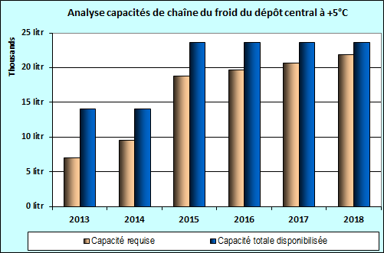

Graph 4: analysis of the positive cold chain capacity at the central level in 2013

  - Wilaya warehouses (regional)
- In 2013, five regions out of the country's thirteen presented insufficient positive storage capacity for vaccines, including with the introduction of PCV-13. The new equipment that is in the process of being allocated should enable the discrepencies identified to be addressed.
- In 2014, with the introduction of the rotavirus vaccine, only two regions will have sufficient cold chain capacities. The current capacity-strengthening efforts will allow the gaps to be filled in all of the warehouses.
- Additional cold chain requirements for the introduction of new vaccines were estimated with the technical support of UNICEF and the WHO. In total, more than 35 new solar refrigerators, 05 freezers in the process of being purchased through UNICEF for an estimated cost of $ 112 143.22.

  - Moughataa Warehouses (district)

Currently only nine districts out of the country's 55 present a certain cold chain storage capacity deficit for the introduction of the PCV-13 vaccine. New equipment is in the process of being allocated to make up the existing gaps and cover future needs for the introduction of the rotavirus and MenAfriVac vaccines and the IPV (the MenAfriVac is planned for a mass campaign so its use will free up space).

The table below summarizes the available storage capacity per level of the supply chain pyramid:
Available storage capacity per level
Level | Net positive storage capacity available (in L) | Net negative storage capacity available (in L) | Comments
National Level | 21 259 | 3 662
Regional Level | 3 312 | 3 499 | 10715L awaiting installation
Moughataa level | 4 607 | 3 627
HC and HP level | 8 033 | 630 | 1450L in the process of being installed
Total | 37 211 | 11 418 | 12 255 L

On the basis of the cold chain equipment inventory carried out in March 2013, 360 appliances (refrigerators and freezers) have been ordered by the State, with 175 of the refrigerators powered by solar energy without a battery (SDD) and 185 electrical appliances including 125 refrigerators and 60 freezers, to progressively replace gas-fueled appliances and those that have been amortized on one hand and on the other to make up the deficit observed at certain levels.
Added to this number are approximately 90 cold chain appliances ordered with meningitis funds, through UNICEF in the form of refundable purchases, the procedures will be faster and we think that by the end of the year 2014, the entire stock will have been changed and the operational level will have solar cold chains to replace the gas ones.

  - Waste management and injection safety

Auto-disable syringes and safety boxes have been used by immunisation services since 1996. The injection safety strategic plan 2002-2006 enabled additional resources to be mobilized thanks to the GAVI application to build incinerators in 40% of the Moughataa (districts). The majority of these incinerators are out of order due to a lack of maintenance. But one of the major weaknesses is the lack of regularity in the destruction of filled safety boxes, due to the excess work load (only one nurse per health post), the lack of training especially for newly recruited and assigned personnel, lack of supervision and sometimes the lack of financial means to install pits adapted for burning and burying. Thus in the framework of the EPI and through the vaccine independence initiative, Mauritania has developed an implementation plan for the national injection safety strategy that hinges on the following points:
- Training/recycling/supervision of health personnel (public and private sector) in inventory management, on injection safety, on rationalizing prescriptions and on waste management.
- Making the budget line for the purchase of vaccines and consumables permanent
- Regularly supplying injection materials, samples and single-use consumables
- Information, education, communication towards the community on injection safety (HABIB)

3.6 Health worker training and supervision

At the introduction of each vaccine, the technical committee designs, develops and endorses a training curriculum, a technical guide, educational materials, and management tools. These materials are reproduced and utilized for cascaded trainings: training of trainers at the Central level, at the Regional level and training providers at the district level. The technical guide addresses all of the modules, thus allowing the Health Workers to acquire better capacities of organization, management, AEFI surveillance and monitoring-evaluation of the activities related to the introduction of the IPV.
Likewise, the Social Mobilization sub-committee designs, develops and endorses communication materials, which are reproduced and dispatched at all levels. These materials include banners, posters, informational pamphlets and radio and television commercials.
The Monitoring and Evaluation sub-committee develops a supervision plan (before, during and after the launch of the IPV). The supervision grid is then updated to account for IPV introduction-related factors. All supervisors are trained on the introduction of the
IPV and on filling out the supervision grid. Supervision reports are used and shared during analysis and data consolidation meetings in order to draw good practices from them and formulate recommendations intended to correct the weaknesses observed.
A post-introduction assessment of the IPV is planned starting in October 2015

In the framework of the IPV introduction, it will be necessary to give details on training and supervision needs and the source of financing for activities

3.7 Risks and challenges

The main programmatic risks and challenges in the introduction of the IPV relate to different areas: financial, programmatic, related to community mobilization on the introduction

Risks/Challenges | Comments | Measures
Financial | Major financial resources from diverse sources (State and partners) that could be compromised in case of commitments of one party | Advocate to the State and other partners with a view to mobilizing additional resources within the time frame to supplement the GAVI grant and reduce the financial risk.
Programmatic | risks are relative to multiple injections with three injections (Penta3, Pneumo3 and IPV), the risk of confusion for the injection site during the same contact, and AEFI. | A specific communication plan will emphasize interpersonal communication, outreach communication with the help of manuals that will be developed and disseminated to this effect in order to minimize these risks.
Programmatic | The exposure of vaccines to freezing temperatures, not following the open vial policy and excessive vaccine wastage
Programmatic | Questioning of the population on the administration of 2 polio vaccines administered at the same time (OPV3 and IPV)
Programmatic | Likely cases of AEFI | The surveillance and management of AEFI cases will be strengthened through setting up an AEFI management committee from the peripheral level to the regional and central level

Certain challenges such as rumors were not listed as well as proposals for solutions/measures taken to resolve these challenges and risks apart from the financial problems

4. Situational analysis of the immunisation program
4.1. General country context

4.1.1. Demographic Data
The Islamic Republic of Mauritania is located between the 15th and the 27th parallel north and covers an area of 1 030 700 square kilometers. It is bordered to the north by Morocco and Algeria, to the east and south-east by Mali, to the south by Senegal and to the west by the Atlantic Ocean.

In 2014, the population of Mauritania is estimated at 3 495 863 inhabitants, with an average density of approximately 3 inhabitants per square kilometer. This population is predominantly young. The crude birth rate is 40 per 1000 and the life expectancy at birth is 51 years. The annual demographic growth rate is 2.4% (RGPH2000).

4.1.2. Health indicators
The principal health indicators of EDSV-MICS-2011 show that progress has been made but that infant and maternal health remains of primary concern.
Table: health indicators are the following:
Indicators | Level
Life expectancy at birth | 51.3
Women of Childbearing Age | 23%
Infant Mortality Rate | 74/1000
Under-five mortality rate | 117/1000
Maternal Mortality Ratio | 626 /100,000
Periodicity | 35 months
Source: MICS 2011

Mauritania has 4 cities, namely Nouakchott, which is the capital of the country, Nouadhibou the administrative center of the wilaya of Dakhlet; Nouadhibou is the economic capital of the country, and Kiffa and Sélibaby are agro-pastoral regions.

The population is very unevenly distributed, very low in the northern wilayas with densities below 0.5 inhabitant/km2. The South and South-eastern areas are the most populated with densities that can exceed 10 inhabitants/km2.

Figure 1 Mauritania on a map

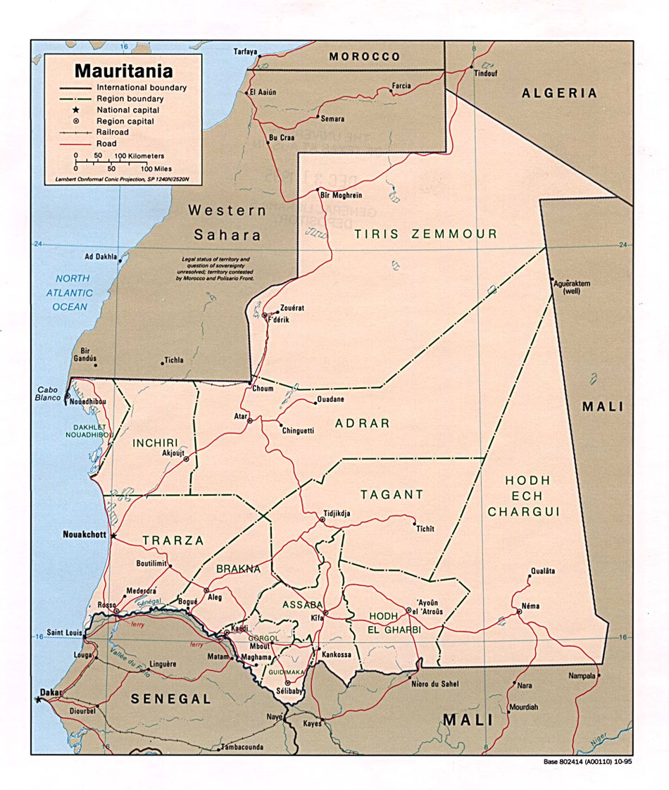

Mauritania has just come out of a transition stage that lasted four years (2005-2007). Then, between 2008 and 2009, an electoral process led to the adoption of a democratic constitution, municipal, legislative, senatorial and presidential elections. Since that time, a democratically elected president of the republic has led the country.
Legislative and municipal elections were planned in November 2013 and presidential elections in June 2014. Political stability exists since the last elections in spite of the proximity of the crisis in Mali.

4.1.3. Economic situation

Mauritania was one of the first countries to adopt, in a participatory manner, a Strategic Framework to Combat Poverty (CSLP), the central document for the country's social and economic development policy, which is based on a long-term view (2015) including, in particular, the full attainment of the Millenium Development Goals (MDG).
Between 2006 and 2010, economic growth was established on average at 3.7% not including oil, and 4% with oil included, or less than half of the forecasts, which counted on 9.4% growth during said period. This situation can mainly be explained by: (i) the poor results noted as regards the oil industry, (ii) the international food, energy and financial crises, and (iii) the different institutional changes that the country experienced during this period.
The vision of the CSLP is based on the four strategic lines identified in the past, which remain relevant: (i) the acceleration of growth and maintenance of macro-economic stability, (ii) the integration of growth in the economic sphere of the poor, (iii) the development of human resources and the expansion of basic services, and (iv) improved governance and strengthening of capacities. These strategic lines will be complemented and supported by a new major orientation: the strengthening of steering, monitoring, assessment and coordination.

In the framework of the first line, the efforts will concern (i) setting up economic policies based on the reestablishment of great macro-economic stability, (ii) maximizing the effects of the oil industry (iii) reforming the financial system (iv) markedly improving the business climate and (v) strengthening and development of support infrastructures for growth.

The second line will emphasize the development of productive activities accessible to the poor and adapted to areas where they are concentrated, in particular (i) the substantial reduction of the gap in socio-economic infrastructures, (ii) the promotion of access to appropriate financial services, (iii) the development of professional training and the promotion of small and medium business, and (iv) the improvement of productivity.

The third line must lead to an improvement of living conditions for the poor in the short term and to putting in place for the long term conditions favorable to sustainable growth.

The fourth line will enable (i) the rule of law to be consolidated, (ii) improvement in economic and environmental governance, (iii) increased decentralization, (iv) a modernized civil service, and (v) deepening the participative approach.

Finally, to this is added the set-up of a system and appropriate mechanisms for coordination, monitoring and evaluation which will allow an effective management of the social and economic development policy. In particular, it is a matter of (i) improving coordination within the Government to provide a sequenced and integrated implementation of priority actions, (ii) align and harmonize the APD in accordance with the Declaration of Paris, (iii) to rationalize the existing devices, and (iv) to regularly produce information and analyses relevant to the monitoring of CSLP implementation.

To measure the progress accomplished in the course of the second phase of the CSLP, the government fixed as objectives: (i) to bring down the incidence of poverty to less than 35% at the national level, to less than 45% in rural areas and to less than 15% in an urban setting, (ii) ensure an average annual economic growth rate of over 10% over the period, (iii) ensure universal access to basic education, (iv) bring down the illiteracy rate of adults aged over 15 years of age to less than 20%, (v) to bring the coverage rate in primary healthcare costs in a radius of 5km to 90% (vi) to bring down the infant mortality rate, the under-5 mortality rate, and the maternal mortality rate respectively to less than 60%, 70% and 400 per 10,000, and (vii) to bring the rate of access to safe drinking water in urban areas to 48% and the coverage rate in rural and semi-urban settings to 62%.

In order to reach medium- and long-term objectives, actions planned in the framework of the second phase of the CSLP will be carried out according to the following four types of priorities:
- 4 areas of priority: education, healthcare, hydraulics and infrastructures (transportation, energy, telecommunications, etc.),
- 2 priority zones: the arid rural lands and at-risk neighborhoods,
- 2 priority horizontal actions: (i) developing a National Strategy Plan for Land Use (SNAT) incorporating a long-term forward-looking view of the country (Mauritania 2030), with, in particular, the implementation of PDALM (already available), and (ii) adopting the National Action Programme for the Environment (PANE), as an important step in fully taking into account the horizontal nature of environmental issues.
- 1 priority work method: cooperative, coordinated, and monitored implementation of the CSLP.

4.1.4. Health System.
- National Health Policy

The different health indicators have not really changed over the last few years. The Infant Mortality and Malaria Survey (EMIP) of 2003-2004 shows that the under-five mortality rate has changed little since 1990; it went from 123 % in 2004 to 118% in 2011 according to the preliminary results of the MICS. The fertility index (FI) stabilized at around 4.6 over the period 2000-2004. The HIV/AIDS prevalence rate (HIVPR) also remained relatively stable, around 0.5% in pregnant women. According to the SNIS data and the health map, 67% of the population is located within a 5 km radius of a health facility. However, the usage rate of facilities located less than 5km from the household is decreasing, going from 73% to 58.2% respectively in 2000 and 2004. It has experienced a dip in rural areas in particular, 55% in 2000 compared to 34.5% in 2004.

Faced with this very lackluster health situation, the right to healthcare is a fundamental human right of every Mauritanian citizen. The national social and health policy (PNDS 2012-2020) aims for sustainable improvement in the population's health, as well as mitigating the impact of poverty on the most vulnerable groups. Leading into the year 2015, the health policy will have encouraged the set-up of a modern healthcare system, one that is proactive, effective, accessible to the population of the whole country, independently of the place of residence, educational level, age, sex, origin, economic status, etc. This healthcare system will have contributed in a significant way to improving the quality of life and life expectancy. The health policy in collaboration with the other sectors will make it possible to combat poverty and thus conquer the diseases linked to poverty and ignorance. To do this, the emphasis will be placed on (i) empowering the populations (ii) community participation and (iii) intersectoral collaboration in the context of harmonious social and healthcare development.
The goal of this Mauritanian health policy is to improve the state of health and social protection of the populations through access to quality social and health care. This implies the existence of an integrated healthcare system in which all of the actors, in particular users and communities, participate in an effective and responsible way.
The current policy targets mother and child healthcare, the fight against large epidemics and emerging diseases as priorities.
- As regards mother and child health, priority actions that have been undertaken over the past several years must be continued in the aim of reducing maternal mortality by three quarters and infant mortality by two thirds by 2015.
- It is also advisable to improve nutritional status in order to contribute to reducing mortality and morbidity attributable to malnutrition, including deficiencies in micronutrients in children under 5 years of age and pregnant women (vit A deficiency, anemia, iodine deficiency disorders).
- With regard to large endemics and emerging diseases, by 2015, efforts should aim to:
- stabilize HIV/AIDS prevalence below 1% in the general population and manage all new reported cases,
- reduce the prevalence of malaria, hepatitis B and tuberculosis,
- develop prevention, screening and control actions for non-transmissible emerging diseases.

- In the area of social protection, the current policy should ensure management of health care for the majority of people in situations of great poverty and social exclusion.
- Health System Organization
The organization of the health system is copied from the administrative divisions; it has a pyramidal structure and includes three levels:

The central level groups together the Minister's cabinet, the Secretary General, the Inspectorate-General of Health, the Central Directorates with their departments and divisions as well as the health programmes;
The intermediate level which, in addition to its coordinating role, today plays the role of the operational level, which is why there are problems with consistency in the system; the Regional Directorates for Health Action (DRAS) are found at this level, which include regional health services;
The peripheral or departmental (Moughataa/district) level is made up of Moughataa health units (CSM).

On the technical level, the system is made up of three levels of service, namely:
At the first level (Moughataa/district) 2 types of facilities can be found:
- Health Posts (HP) numbering 570, are run by one or two nurses and one midwife, and are located in the large rural communes and large, difficult to access communities.
- The district Health Centers (CSM) number 56, 13 of which are type A and 43 type B centers (definition). They are managed by chief doctors and provide preventive and curative services, as well as emergency care and observation, according to the level of technical facilities.
At the second level (intermediary) are the 12 hospitals (Néma, Aioun, Kiffa, Kaédi, Aleg, Rosso, Boutilimit, Atar, Chinguetti, Nouadhibou, Tidjikja et Sélibaby); the hospitals of Nouadhibou, Kiffa, Néma, Aioun, Kaédi and Rosso have managerial autonomy;
The third level (national) comprises public referral facilities:
The National Hospital Center (CHN);
The Neuropsychiatric Center (CNP);
The National Center for Public Health Research (CNRSP);
The National Orthopedic and Functional Rehabilitation Center (CNORF);
The Sheikh Zayed Hospital Center of Nouakchott
The National Blood Transfusion Center (CNTS);
The Military Hospital of Nouakchott.
The National Center for Cardiology (CNC)
The Mother Child Hospital Center (CHME)
The National Center for Oncology
The Amitié Hospital Center of Nouakchott

Added to these facilities are six establishments that provide training and recycling of healthcare personnel, the National School of Public Health of Nouakchott (ENSP), the School of Public Health of Kiffa (ESPK), the one in Néma, in Selibaby, in Rosso, and the Medical School of Nouakchott

In addition to public health facilities, the private sector, which came into being in 1988, contributes significantly to health coverage. It currently includes:
12 medical clinics including several specialties with an average of 10 hospital beds;
22 outpatient medical offices managed by doctors;
15 care offices managed by nurses;
14 dental offices;
1 non-profit ophthalmological foundation

The health centers and health posts immunize systematically; only three referral facilities immunize out of the 11, currently awareness-raising and advocacy are in progress to integrate immunisation in all of the referral centers. Certain private clinics immunize with the vaccines provided by the programme.

4.1.5. History and development of the EPI

The Expanded Programme on Immunisation began in Mauritania in 1977 in two experimental areas of Trarza, KeurMacène and Rosso.
It then underwent a progressive expansion to become spread around the country in 1984. It used two strategies:
one fixed strategy through health facilities.
one mobile strategy through mobile teams in rural areas.
In 1985, two other strategies were introduced:
the advanced strategy, which consists in carrying out activities around fixed facilities by moving teams within a 5 to 10 km radius.
the acceleration strategy through, first of all, municipal immunisation days, then from 1989 to 1994 Maghreb immunisation days and then with the national immunisation days (NIDs) starting in 1995 aiming to eradicate eradication polio, then to control measles.

In the framework of the Expanded Programme on Immunisation, the national immunisation policy recommends immunizing children 0-11 months and pregnant women.
For the children, all the programme antigens must be planned to be administered before the age of one year, in five vaccination contacts. Initially, it was a question of vaccines against tuberculosis (BCG), polio, diphtheria, tetanus, whooping cough (DTP-polio) and measles (VAR). The hepatitis B vaccine was introduced in this schedule starting in March 2005 and the vaccine for haemophilus influenzae in 2009. The hepatitis B vaccine dosed at birth was introduced in 2012, and the one for pneumococcus planned for November 2013. The EPI plans to introduce the rotavirus vaccine at the end of this year, organize a mass campaign against meningitis A in the 33 Moughataas and apply for the introduction of two new vaccines, the IPV and the yellow fever vaccine.
The supportive components relate to programme management, funding and capacity building.
- Programme management and coordination
The EPI programme reports to the basic health and nutrition directorate, strategic coordination is provided by the interagency coordination committee chaired by the Minister of Health. The EPI is headed by a coordinator and several heads of divisions including logistics, training, data management and social mobilization. It is represented at the Wilayas level and the districts by the EPI regional and district focal points. The operational level is made up of health centers and posts and suffers from a lack of personnel.
- Strengthening of Personnel Abilities
In Mauritania, EPIVAC trainings as well as training on immunisation techniques are carried out in an ongoing manner in all of the Health Districts. The external review of the EPI carried out in April 2014. The EPI focal points at the DRAS and Moughataa (Districts) level were trained. This training was on the subject of (i) injection materials and vaccine management, (ii) conservation and handling of vaccines, (iii) logistics and cold chain maintenance, (iv) surveillance of EPI target diseases, (v) injection safety and AEFI, (vi) public relations and social mobilization, (vii) monitoring of the EPI and filling out materials and (viii) supervision. Two group meetings are held each year for the regional focal points and one for the district focal points.
- Supervision

Supervision of the regional level by the central level and of the regional level to the peripheral level (HC and HP) is not always regular because of the instability of resources and the size of the country. However, since 2010, the EPI has started to supervise the regional level (two times per year). In addition, the integrated supervisions of the regions to the districts and of the districts to the health posts are more and more organized, with the resources made available by the government as well as those received from partners in development. An orientation and EPIVAC-type formative supervision workshop, with an objective of improving immunisation coverage.
- Monitoring of activities
The monitoring of coverages and drop-out rates is not always effective at the level of all of the health centers and posts. The internal monitoring meetings at the level of health centers and posts are not regular, as well as the quarterly meetings organized with all of the players in the system to identify difficulties and approve corrective solutions. An effort must be made to mobilize resources and logistics necessary for monitoring activities. Meetings for data analysis and consistency are regular at the central and regional levels.
In 2013, the introduction of monitoring curves for coverage at all levels of the health pyramid contributed to improving the quality of data.
- Infrastructure and Equipment
The infrastructures are present at the central level and at the Wilayas (regions) level, but are more and more dilapidated at the health post and health center level. A supervision vehicle was purchased by UNICEF in 2012 for the programme. A truck and a pick-up are in the process of being purchased for distributing vaccines and inputs. Two cold rooms, one 30m3 for the central level and the other 10m3 for the Nouakchott health delegation are in the process of being installed. 200 refrigerators and freezers have been ordered, the RCW50 appliances are being replaced by solar refrigerators.
- The EPI's Permanent Funding Mechanisms
EPI resources come from State financing and from development partners, in particular agencies from the United Nations system and from civil society organizations.

4.1.6. Operations of the Expanded Programme on Immunisation
- Routine EPI
After having recorded very poor performances up until 2000, the immunisation coverage rates for EPI routine antigens experienced a spectacular progression from 2001 to 2002, thus enabling an increase from 26% for DTP3 in 1999 to 82% in 2002, then a decrease to 75% in 2007. These performances were slowed between 2008 and 2010 in spite of the introduction of the pentavalent, with a significant drop in this coverage rate, which decreased from 75% in 2007 to 64% in 2009 and 2010. (Graph 1)
From 2011, a significant improvement in the penta3 immunisation coverage was noted, up to 78.4% in 2012 and 79.3% in 2013, essentially due to advanced and mobile activities, to training and supervision, to data control and to good coordination at the central level.

Graph1: Progression of EPI antigens immunisation coverage rates for routine from 2002 to 2013 (source: annual routine EPI reports)

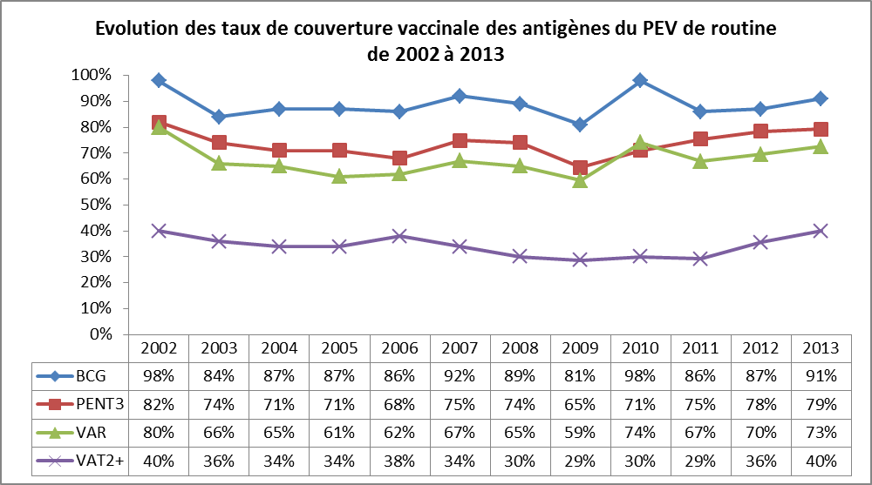

Source: annual routine EPI reports
In 2010, 17% (9/53) of districts had an immunisation coverage for DTP3 above 80%, hence the necessity of emphasizing poorly performing districts through sustainable and lasting strategies in order to reach regional and global objectives by 2015 while making sure to expand the number of antigens to protect children (pneumococcus and rotavirus).

Figure 2: Cartography of the Moughataas (districts) as a function of the DTP3 immunisation coverage rate in 2011 and 2012

2013.
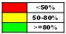
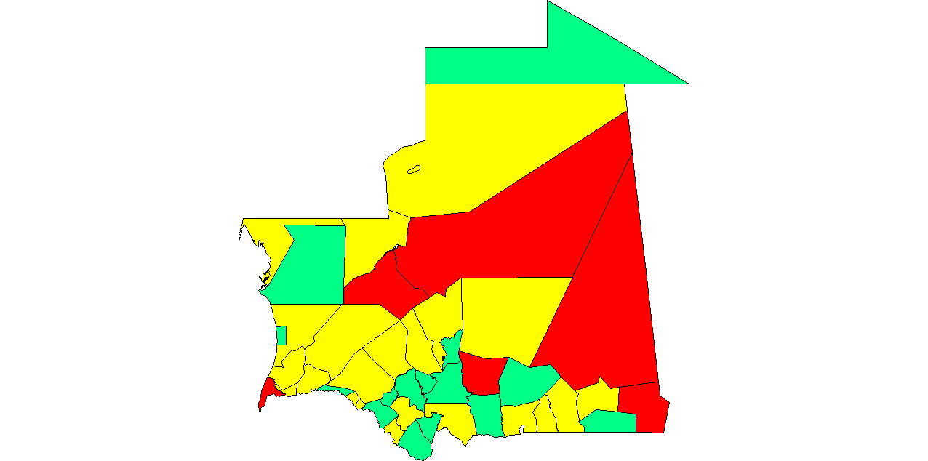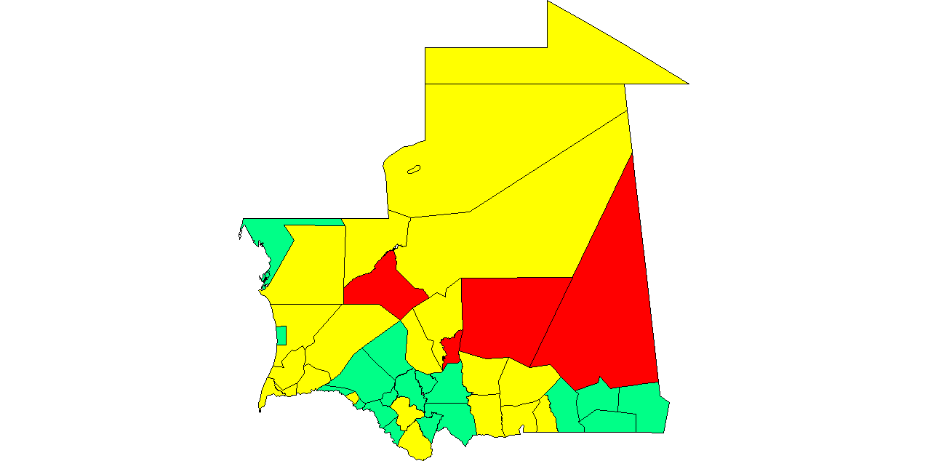

At the end of 2013, 22 districts out of the country's 53 recorded a coverage greater than 80%.
Note that no epidemic was observed in the country in 2013.

Graph1: Progression of OPV3 coverage rates from 2002 to 2013

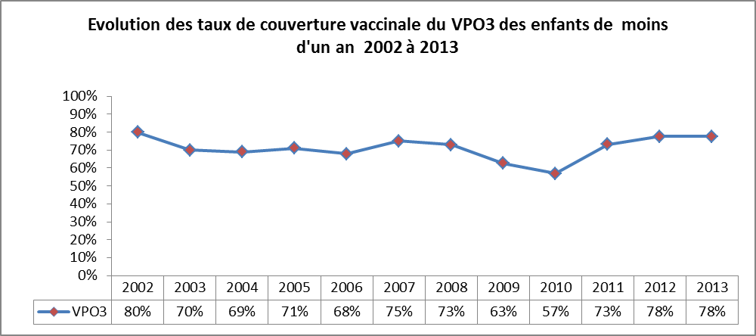

Source: annual routine EPI reports

Figure 2: Cartography of the Moughataas (districts) as a function of the OPV3 immunisation coverage rate in 2011 and 2012

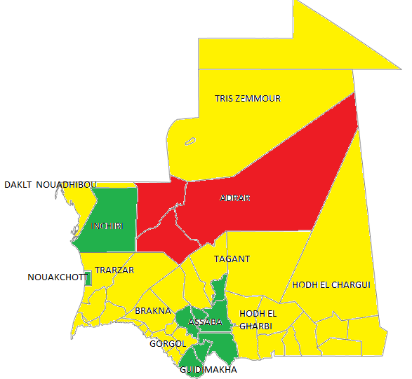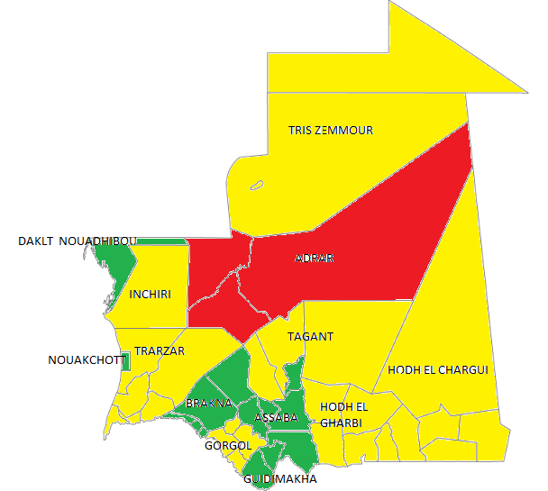
2013
2012
IC<50%
50<IC<80%
IC>80%

The main reasons for non-immunisation that emerged from the last national immunisation coverage survey of 2004 hinge on the following points
- lack of information (41%)
- the absence of the vaccinator and/or the nonavailability of the vaccine (14.6%)
- an immunisation site that was too far away (14.2%) and not being aware of the need to return to have a child vaccinated (8.2%).

The reasons related to immunisation services (vaccinator absent, unavailable vaccine, lack of interpersonal communication, etc.) are the most important ones.
National averages hide significant disparities in terms of immunisation coverage or drop-out rates.
At the same time, the reasons related to negative biases towards immunisation (fear of side effects, mistaken ideas, lack of trust, false rumors, etc.) only represent 3.1% of reasons given.

- Polio Supplementary Immunisation Activities (SIAs)

The adjacent graph translates the country's ability to organize a mass immunisation activity and this experience remains an important asset and a sufficient basis that the country will be able to use to introduce new vaccines such as the one for meningitis, which can copy the same way of proceeding.

Graph 2: Average annual immunisation coverage rate (Polio NID) from 2000 to 2013

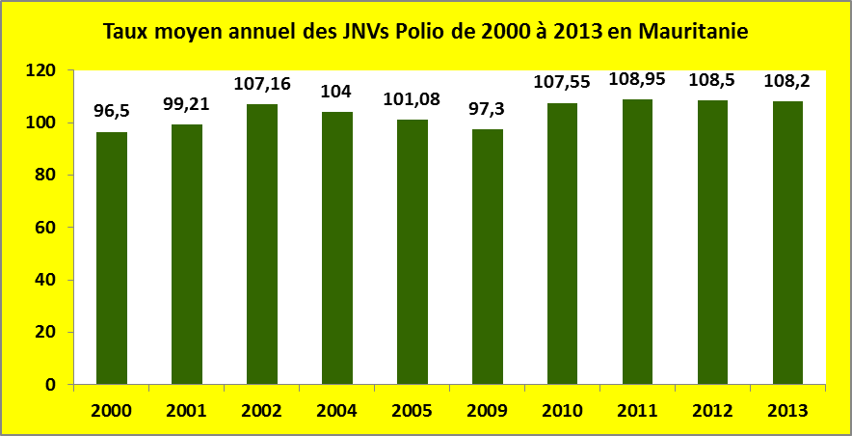

Graph 2 above shows that the NIDs against polio were continued from 2000 to 2005 then from 2009 to 2012 following the reimportation of the wild virus in October 2009. These days synchronized with the other countries of western Africa have always recorded levels of immunisation coverage above 95%. These immunisation coverage figures pose a problem of reliability with regard to the sometimes high rates of unimmunised children according to data from independent monitoring. The reasons given hinge on the lack of reliability of the denominator, of the lack of knowledge of the children's ages, and the population's fondness for having their children vaccinated even beyond the age range targeted by the campaign.
Despite a certification in 2007 and satisfactory AFP performance indicators for the past few years, the country was subjected to a reimportation of WPV with 13 cases in 2009 and 5 cases in 2010. The last detected case goes back to 28 April 2010. This year, the Regional Certification Commission for Africa (ARCC) examined and approved the application for pre-certification as a polio-free country.

  - Findings from recent programme reviews

Highlight key competencies/strengths of the immunisation programme that make it feasible to carry out IPV introduction including recent changes to address any weaknesses previously identified.
An outside assessment of immunisation activities was carried out with the technical support of international consultants. The implementation of preliminary recommendations (until such time as the review report has been finalized) coming out of this outside assessment will contribute to facilitating the introduction of the IPV
The implementation of the EVM improvement plan of March-April 2013 enabled the storage capacity to be increased through the acquisition of cold rooms and solar refrigerators for the vaccines and to provide training for workers responsible for the EPI at the regional and district level on knowledge and use of management tools and monitoring of vaccines and the cold chain (DVD/MT, SMT rehabilitation, fridge tag, etc.). Getting the monitoring of temperatures to standard at the national level through the acquisition of continuous temperature recorders, multilog to replace fridge tags and improving inventory management were noted.
Following the recommendations from the post-introduction evaluation for PCV-13 planned to be carried out by the end of the year will enable improvements in the preparations for introducing other new vaccines, in particular the IPV.
The opportunity offered by several immunisation campaigns (measles, meningitis, polio) being organized in the last semester of the year 2014 will facilitate the meeting of the different players who will participate in the EPI at all levels and will facilitate the implementation of recommendations from the different assessments made in order to allow the programme to be strengthened for introducing new vaccines.

Summarize findings from recent programme reviews, indicating whether the recommendations are part and parcel of a subsequent national Plan of Action that will be adopted soon, and describe the monitoring of recommendations being implemented and how these will impact on the proposed new vaccine introduction.
This year, the country received an external review of the EPI and of the Effective Vaccine Management Assessment with strong points and points needing improvement.
The recommendations that came out of these assessments will be incorporated in the Annual Work Plan of the EPI.
The implementation of planned activities as well as of several immunisation campaigns planned by the end of the year 2014 will contribute to improving the EPI in Mauritania.
The constraints that we could be confronted with are the lack of human resources. It would be very helpful to have medical students and students from training schools for nurses contribute their services.
Having a large number of activities scheduled in addition to the routine in the second half of 2014 is a major challenge.

Highlight whether there are resource constraints in implementing recommendations from recent reviews and how these will be overcome.
Describe any previous experience with introducing a new vaccine and how lessons learnt from these experiences will be used to ensure a smooth introduction of the new vaccine under consideration.

The experience of introducing new vaccines in Mauritania shows the importance of emphasizing the following points:
- Establish a detailed time line for introduction activities at the regional and district levels;
- Use the opportunity of pre-introduction trainings to recycle the providers on cold chain and vaccine management in all of the districts;
- Make specimens of the new vaccine available to providers during training;
- Conduct close monitoring after training providers through formative supervision, in order to continue strengthening personnel capacities on the new vaccine;
- combine mass communication with increased continuous local communication and also advocacy at all levels;
- Make sure that all of the health districts introduce the new vaccine at the same time;
- Strengthen the implementation of advanced strategy immunisation in the health areas;
- Strengthening the AEFI management system;
- Strengthening the waste management system.
Otherwise, the recent experience of IPV introduction in several developing countries highlights the importance of emphasizing:
- collaboration in all stages of planning and implementation of the project with the different ministries involved;
- setting up a rumor management system;
- Awareness-raising of community leaders, religious leaders, local administrative authorities, and civil society organizations (NGOs, Associations).
- From preceding reports, when the lessons learned are taken into account to follow a timeline using that information, we observe an easier introduction of the new vaccine.
- 4.4 Stock management
In the framework of the WHO-UNICEF initiative known as EVM (Effective Vaccine Management), an assessment was carried out in March 2014 thanks to the support of the WHO and UNICEF. The assessment concerned warehouses of the central, intermediary and peripheral levels. It was carried out according to international standards using the new GEV/EVM assessment tool on the basis of the following 9 criteria:
Arrival procedure for vaccines
Vaccine storage temperature
Storage capacity
Buildings, cold chain and transportation equipment
Maintenance of buildings, cold chain and transportation equipment
Stock management
Vaccine and consumables distribution
Vaccine management (correct and effective use of diluents, of VVM, OVP monitoring of management indicators, etc.)
Information system, support functions
The following table presents a summary of the results by criterion and by level:

- The following table presents a summary of the results by criterion and by level:
- Table 9: the summary of EVM results by criterion and by level 2014 Effective Vaccine Management Criteria | - Supply-chain levels
 | - National | - Region | - Districts | - HC
- Arrival procedures for vaccines | - 82%
- Temperature monitoring | - 85% | - 82% | - 76% | - 60%
- Storage and transport capacity | - 86% | - 66% | - 64% | - 63%
- Buildings, cold chain equipment, and transportation | - 79% | - 70% | - 74% | - 64%
- Maintenance of equipment | - 86% | - 56% | - 42% | - 42%
- Stock management | - 80% | - 54% | - 54% | - 40%
- Vaccine distribution | - 36% | - 59% | - 56% | - 68%
- Vaccine management | - 98% | - 76% | - 79% | - 66%
- Information system and management support functions | - 60% | - 57% | - 52%
- Sources: EVM 2014 results

Comparison of EVM 2010 and 2014 central level

This evaluation enabled the country to clearly identify the strengths and weaknesses of the EPI supply chain. On the whole, a clear improvement can be noted, with three (3) criteria out of the nine that have not met the required level of performance. Two of the three criteria have been identified as being priority: distribution, and the information system and management support, requiring priority actions.

Give solutions recommended to solve stock management problems at all levels (Present the stock management problems and their solutions in a table)
At the end of the EVM assessment, recommendations were made and an improvement plan was suggested to fill in the gaps:
- Strengthen the national level through a qualified and trained person to help the national logistician in monitoring the cold chain and vaccine management (manual and computerized registries for vaccine stock management).
- Generalize and systematize the use of management tools and monitoring of vaccines and consumables: SMT at the central level and possibly at the regional level, DVD_MT at all levels, in particular at the district level.
- Equip the national level with Multilog continuous temperature data recorders as a replacement for fridge tags.
- Improve monitoring through regular supervisions at a sustained pace, two at the central level, four at the regional level and six at the district level
- Make the use of voltage regulators mandatory to protect EPI cold chain equipment;
- Systematize and compel meticulous use of inventory registries
- Institute an incentive award for the benefit of personnel responsible for immunisation;
Assign MK 304 refrigerators to the Moughataas level to facilitate the separation between the Moughataa warehouse and the health center warehouse

5. Monitoring-Evaluation

5.1 Updating of the monitoring instruments

The EPI health information system will be updated to take into account the introduction of the IPV. The immunisation data collection tool for the District (DVD/MT) will be reupdated and already takes the IPV into account. The other EPI management tools will have to be revised and adapted. Training so that workers will be well trained to use them.

Measures for regular monitoring of implementation will be put in place as soon as the new vaccine is introduced, in order to be able to detect and correct all of the deviations with regard to recommended practices. A post-introduction evaluation for the process as a whole will be scheduled starting from the end of the first year of introduction. We will use information technology to improve the data transmission system. The monitoring and evaluation indicators are the rate of completeness, the rate of promptness, the average cost per immunised child, the drop-out rate, the rate of recovery for drop-outs and the immunisation coverage rate, the accuracy rate for data (organization of periodic DQS)

.
- Show how peripheral facilities will take into account the different problems of gathering sex-disagreggated data and their dissemination and see to it that it will be possible to incorporate sex-disaggregated data on the distribution of vaccines in all of the immunisation monitoring forms.

5.2 Adverse Event Following Immunisation (AEFI) surveillance

Mauritania has a system of AEFI surveillance to detect any expected or unexpected adverse occurrence. This system will be strengthened with the help of the introduction of new vaccines (MenAfriVac, PCV13). The AEFI surveillance system will be further strengthened when the failures from the previous fiscal year have been taken into account.

In the framework of AEFI management, a pool of trainers benefitted from capacity strengthening at the Tunis pharmacovigilance center to accelerate the implementation of AEFI management with WHO support. Outside of mass campaigns using injectables during which notification and management are systematic, AEFI is practically absent in routine. The revision of training modules and the training plan should take these aspects into account.

Two severe cases of AEFI that were unfortunately fatal during the last national immunisation campaign against polio combined with measles called into question the AEFI surveillance system. Since then, several awareness-raising campaigns involving the press were implemented for surveillance and early detection, and also for mass communication on cases of AEFI. Trainings on AEFI will be organized for all of the personnel involved in immunisation during this year. Capacity strengthening of healthcare personnel on immunisation services will be accomplished through developing and implementing a training plan for healthcare personnel involved in immunisation on "Immunisation in Practice" by giving priority to the district level.
- Organizing training on AEFI, Accountability Analysis and Crisis Communication for personnel with responsibility for training/supervision of immunisation services
- Strengthening formative supervision by emphasizing peripheral health facilities
- Developing simple technical guide tools in the local language (on-the-job-aids) intended for less qualified health workers on the main immunisation acts (immunisation schedule, vaccines and their solvents, storing vaccines in the refrigerator, use of safety boxes, etc.)
The process and procedures for monitoring occurrences of adverse events following the introduction of the IPV at the district level, as well as at the local, regional/provincial and national level will be carried out according to the WHO procedure, in other words detecting the occurrence, notifying the head doctor of Moughataa who must transmit to DRASS, at the central level and thus the investigation team will be called upon to lead this investigation. The data will then be analyzed in order for corrective actions to be implemented. The communication team will work in an inclusive way with the management team and later the system will be evaluated to pinpoint weaknesses and correct them.

Describe in detail the likely consequences of AEFI on the acceptance of vaccines/IPV by the population and by the healthcare personnel and the recommended solutions

6. Advocacy, public relations and social mobilization
6. Advocacy, public relations and social mobilization
The EPI has just equipped itself with a communication plan developed on the basis of a CAP study conducted in 2012 and data from independent monitoring during Supplementary Immunisation Activities (SIA) in particular against polio. The methodology for developing it consisted in first developing micro plans in the 6 districts, which enabled the types of problems, activities, players and coordination at the operational level to be determined, and to be used to design a national plan.
This plan does not give indications specific to IPV, for its introduction was decided on well after the plan's development. However, the question of introducing new vaccines is dealt with in the plan in a cross-disciplinary manner, all while determining the appropriate methods and strategies, IPV included.

- Describe the measures intended to raise awareness of political leaders and opinion leaders on the national/regional level and at the district level on IPV introduction, its benefits for the population and its contribution to the strategy for eradicating polio and the final onslaught against the disease.

The introduction of the IPV and its advantages has already been extensively discussed within the interagency committee in the presence of representatives from key public sectors and from private sectors and civil society. To continue this momentum, advocacy tools emphasizing the end game against polio will be developed for the decision-makers, community leaders, and development partners. A statement will be made to the Ministers Council by His Excellency the Minister of Health and on the occasion of conferences-debates on the introduction of the IPV they will be broadcasted on national radio and television. Informational meetings will be organized in the central administrations of the key agencies such as the Ministry of Economic Affairs and Development (MAED), finance, Education and the Ministry of Social Affairs (MASEF) and with members of Parliament and employers. Administrative authorities at the regional and departmental level will be informed through an official message from the Ministry of the Interior, in regional workshops and if possible, during their periodic meetings with members of the government. In all of these activities, emphasis will be placed on the advantages of the IPV in terms of protecting children from polio and economic repercussions for the country as well as on the commitment of all of these players in favor of immunisation in general and the eradication of polio in particular.

- Describe the development of a communication strategy for IPV introduction at the community level with identification of key messages, communication channels, and methods for greatest impact. Describe, if necessary, the extent to which the results of the assessment of the skills, attitudes, practices and beliefs of the service providers and/or studies of the obstacles to immunisation have been utilized to clarify the public relations strategy for the introduction of the IPV.

The public relations plan on the EPI, the CAP study that preceded it, and the other information available on the CAPs as regards immunisation will be used and if necessary supplemented by a quick collection of data with groups of primary and secondary participants to determine methods, messages and specific channels that are the most appropriate for introducing the IPV. It is on this basis that the micro planning tools will be developed by the Social Mobilization Committee and used by the districts and regions with a view to defining, with all of the local players, the actions to be carried out in a systematic manner and the response plans for particular situations such as rumors, refusals and possible cases of AEFI.

- Describe the process of preparing information, education and communication (IEC) materials, media campaigns, discussion groups and demographic evaluations of the primary target groups, if applicable.

Based on available information and information collected from primary participants, appropriate public relations materials will be developed and tested before being reproduced. Certain messages and materials will be intended for the media, such as television and radio which make up 27% of information sources, according to the CAP 2013 study. The electronic press and widespread mobile telephone use are also channels that for the moment have not been subject to much study. Other materials are intended for relay workers for facilitating group discussions and for identification and response to the particular needs of individuals and communities. Note that the CAP 2013 study showed that community information sources represent 44% with community relays in the lead (23%). Health personnel will also be drawn on, for they comprise the information source in 27% of cases, once again according to the CAP 2013 study.

- Describe the measures that have been taken to organize a kickoff ceremony on a national scale, if necessary, and ceremonies at the sub-national level, if necessary, including the potential promotion of immunisation programmes and the integrated strategies to combat disease.

The kickoff ceremonies make up a key activity in the timeline for the introduction of the IPV and will be key in the future communication plans at the national and regional levels. The agenda for these ceremonies will be drawn up one month before the launch date and regularly updated as the level of participation is determined. Usually, the Minister of Health presides over the ceremony at the national level and invites other ministers to this occasion with the representatives of health sector partners. The social mobilization committee and its divisions at the regional level will take responsibility for mobilizing the local press for the occasion and will submit the schedule of activities that place the IPV introduction in the framework of the fight against disease as a whole and child survival in particular.

- Describe some examples of rumors already encountered that could influence the IPV and the expected impact of this communication

At the level of Moughataa, the Health Center, made up of a unit of curative care and a unit of preventive care, is the reference at the department level. These Health Centers are classified as type A, with a broader range of technical facilities (hospitalization department, a laboratory, radiology department and a dental surgery department) and type B which has more limited technical facilities (hospitalization including a certain number of beds for maternity and a small laboratory).
National Health Development Plan 2012-2020

