Annual Progress Report 2006

Submitted by

The Government of
République de Haïti

to the


Date of submission: Mai 2007
Annual progress report (this report reports on activities in 2006 and specifies requests for 2008, Jan.-Dec.)

*Unless otherwise specified, documents may be shared with GAVI partners and collaborators as well as the general public.
Signatures Page for ISS, INS and NVS

For the Government of Haïti

Ministry of Health: | Ministry of Finance:
Docteur Robert AUGUSTE
Title: Ministre de la Santé Publique et de la Population | Title: ……………………………………
Signature: …………………………………… | Signature: ……………………………………
Date: …………………………………… | Date: ……………………………………

We, the undersigned members of the Inter-Agency Co-ordinating Committee endorse this report. Signature of endorsement of this document does not imply any financial (or legal) commitment on the part of the partner agency or individual.

Financial accountability forms an integral part of GAVI Alliance monitoring of reporting of country performance. It is based on the regular government audit requirements as detailed in the Banking form.

The ICC Members confirm that the funds received from the GAVI Funding Entity have been audited and accounted for according to standard government or partner requirements.

Name/Title | Agency/Organisation | Signature | Date
Docteur Henriette CHAMOUILLET, Rep | OPS/OMS
Mr Adriano GONZALEZ REGUERAL, Rep | UNICEF
Mr Paul TUEBNER | USAID
Mr Nicolas FRELOT | Coopération Française

Signatures Page for HSS

For the Government of ………………..…………………………………

Ministry of Health: | Ministry of Finance:
Title: …………………………………… | Title: ……………………………………
Signature: …………………………………… | Signature: ……………………………………
Date: …………………………………… | Date: ……………………………………

We, the undersigned members of the National Health Sector Coordinating Committee, ……………………………………… (insert name) endorse this report on the Health Systems Strengthening Programme. Signature of endorsement of this document does not imply any financial (or legal) commitment on the part of the partner agency or individual.

Financial accountability forms an integral part of GAVI Alliance monitoring of reporting of country performance. It is based on the regular government audit requirements as detailed in the Banking form.

The HSCC Members confirm that the funds received from the GAVI Funding Entity have been audited and accounted for according to standard government or partner requirements.

Name/Title | Agency/Organisation | Signature | Date

Progress Report Form: Table of Contents

Report on progress made during 2006

  - Immunization Services Support (ISS)
1.1.1 Management of ISS Funds
Use of Immunization Services Support
    - Immunization Data Quality Audit
    - ICC Meetings
  - GAVI Alliance New and Under-used Vaccines (NVS)
1.2.1 Receipt of new and under-used vaccines
1.2.2 Major activities
    - Use if GAVI Alliance financial support (US$100,000) for introduction of the new vaccine
    - Evaluation of Vaccine Management System
1.3 Injection Safety (INS)
    - Receipt of injection safety support
    - Progress of transition plan for safe injections and safe management of sharps waste
    - Statement on use of GAVI Alliance injection safety support (if received in the form of a cash contribution)

2. Vaccine Co-financing, Immunization Financing and Financial Sustainability

3. Request for new and under-used vaccine for 2008

  - Up-dated immunization targets
  - Confirmed/revised request for new vaccine (to be shared with UNICEF Supply Division) for year 2008 and projections for 2009 and 2010
  - Confirmed/revised request for injection safety support for the year 2008 and 2009

- Health System Strengthening (HSS)

- Checklist

- Comments

Text boxes supplied in this report are meant only to be used as guides. Please feel free to add text beyond the space provided.

1. Report on progress made during 2006

Immunization Services Support (ISS)

Are the funds received for ISS on-budget (reflected in Ministry of Health and Ministry of Finance budget): Yes/No
If yes, please explain in detail how it is reflected as MoH budget in the box below.
If not, explain why not and whether there is an intention to get them on-budget in the near future?

Funds received for ISS have been canalized through PAHO/WHO. So far they are not included in the national and MOH budget. But as political and administrative situation normalized – and as higher level involvement is a prerequisite for other lines of funding (New vaccines introduction; and Health System Strengthening) we can expect that it will be the case for these in the near future.

1.1.1 Management of ISS Funds

Please describe the mechanism for management of ISS funds, including the role of the Inter-Agency Co-ordinating Committee (ICC).
Please report on any problems that have been encountered involving the use of those funds, such as delay in availability for programme use.

Program priorities are established on an annual basis with validation by the members of the ICC.
Funds were made available on time in 2006.

1.1.2 Use of Immunization Services Support

In 2006, the following major areas of activities have been funded with the GAVI Alliance Immunization Services Support contribution.

Funds received during 2006 : 0
Remaining funds (carry over) from 2005 44 270
Balance to be carried over to 2007 0

Table 1: Use of funds during 2006*

Area of Immunization Services Support | Total amount in US $ | AMOUNT OF FUNDS
Area of Immunization Services Support | Total amount in US $ | PUBLIC SECTOR |  |  | PRIVATE SECTOR & Other
Area of Immunization Services Support | Total amount in US $ | Central | Region/State/Province | District | PRIVATE SECTOR & Other
Vaccines
Injection supplies | 7 614 |  | 7 614
Personnel | 12 069 | 12 069
Transportation
Maintenance and overheads | 11 295 | 11 295
Training | 3 556 | 1 147 | 2 409
IEC / social mobilization
Outreach
Supervision | 7 475 |  | 7 475
Monitoring and evaluation
Epidemiological surveillance | 2 261 |  | 2 261
Vehicles
Cold chain equipment
Other …………. (specify)
Total: | 44 270 | 24 511 | 19 759
Remaining funds for next year: | 0

*If no information is available because of block grants, please indicate under ‘other’.
Please attach the minutes of the ICC meeting(s) when the allocation and utilization of funds were discussed.

Please report on major activities conducted to strengthen immunization, as well as problems encountered in relation to implementing your multi-year plan.

Major activities conducted to strengthen immunization during the year 2006 included the following:
- Recruitment and funding through state budget of nurses to staff the EPI direction and one departmental direction for health (North Est)
- Funding and supplying logistics for the support activities of the national Direction of EPI to Departmental Direction for Health, including : supervision, cold chain equipments repairing missions, trimestral supply of vaccines and other EPI supplies (syringes, security boxes…)
- Funding and supplying logistics for epidemiologic surveillance activities : investigation of cases, active research, outbreaks response, training of personals involved in surveillance
- Elaboration of actualized training materials and management tools for various components of the routine EPI: Cold chain, vaccine and supply management, epidemiologic surveillance.
- Training of personnels in EPI norms and standards; and training in cold chain management of all personals involved at the departemental level (EPI coordinating nurses; Cold chain technicians ; pharmacist; vaccine store keepers)
- Devising and implementing a national physical inventory of the cold chain which will in the future allow to plan on sound grounds the allocation of cold chain equipments and facilitate their retention in the system
Major difficulties encountered were:
- Difficulty to recruit suitable personals for EPI direction, owing to a shortage of qualified personals interested in working in the conditions offered in/by the Ministry of public health
- Relocalization of central cold chambers as a response to growing insecurity in its former place
- Difficulties to find funding source for the gaz propane used in most cold chain equipments
- Reduction of missions related with the electoral context

Immunization Data Quality Audit (DQA)
Next* DQA scheduled for 2007

*If no DQA has been passed, when will the DQA be conducted?
*If the DQA has been passed, the next DQA will be in the 5th year after the passed DQA
*If no DQA has been conducted, when will the first DQA be conducted?

What were the major recommendations of the DQA ?

Second DQA is scheduled for 2007. It is expected to take place in the months to come (june/july)

Has a plan of action to improve the reporting system based on the recommendations from the DQA been prepared?

YES NO

X

If yes, please report on the degree of its implementation and attach the plan.

Strengthening of the EPI health information system was continued through the supervision and tutorial training by National Direction of EPI of the statisticians of departments in the use of the EPI database.

This allowed to make available a monthly monitoring report of EPI performances, including indicators of completeness of reporting per institution and of vaccines coverages (see example of the end of year report in annexe 1).

Please highlight in which ICC meeting the plan of action for the DQA was discussed and endorsed by the ICC.

DQA was not discussed and thus endorsed in the ICC but this endorsement was taken for granted by the Technical Committee (TC) were it was discussed – and announced - in various occasions. Circumstances are utterly responsible for the delay in the implementation of the DQA, which is considered by TC as not only a GAVI requisite, but potentially useful for the strengthening of EPI.

Please report on studies conducted regarding EPI issues in 2006 (for example, coverage surveys).

In 2006, a DHS-EMMUS survey took place. Its findings related with EPI coverages are presented in the graphics underneath, with comparison the result of results of previous DHS, which took place in 2000

EMMUS 2006coverages | EMMUS 2000 and 2006 coverages
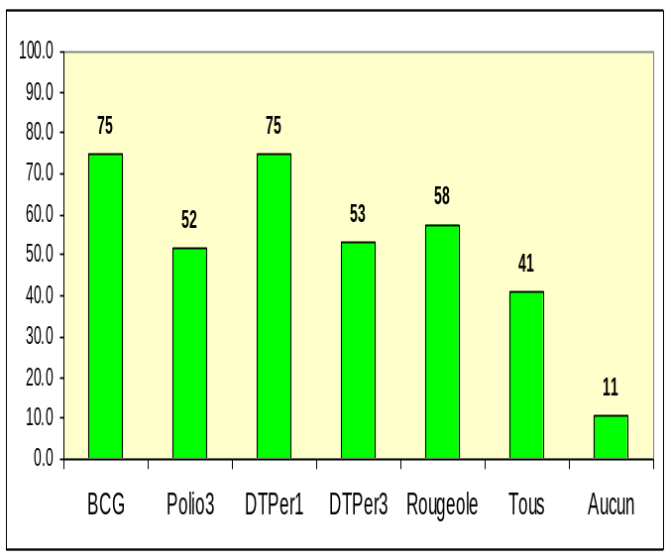 | 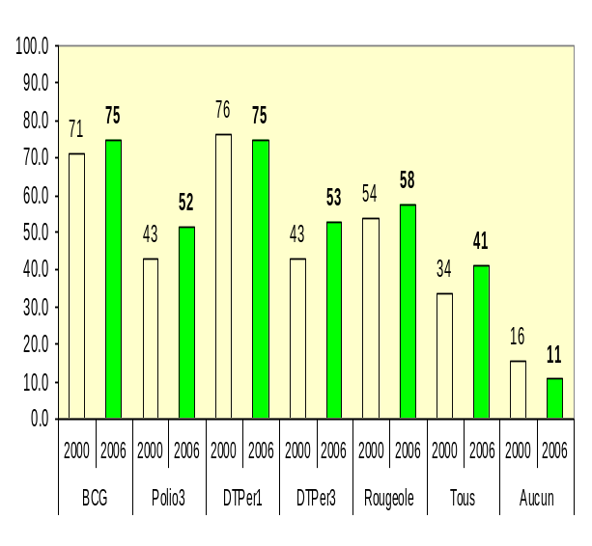
There is some improvement in the BCG, DTP3 and Measles vaccine coverages between the two DHS

1.1.4. ICC meetings

How many times did the ICC meet in 2006 ? Please attach all minutes.
Are any Civil Society Organizations members of the ICC and if yes, which ones ?

ICC met once in 2006; minutes are attached (Annexe 2). There is no civil organization member.

1.2. GAVI Alliance New & Under-used Vaccines Support (NVS)

Haiti has not received funding for GAVI Alliance New & Under-used Vaccine supports

Receipt of new and under-used vaccines during 2006

When was the new and under-used vaccine introduced? Please include change in doses per vial and change in presentation, (e.g. DTP + HepB mono to DTP-HepB) and dates shipment were received in 2006.

Please report on any problems encountered.

There was no introduction of new vaccines in 2006.

Major activities

Please outline major activities that have been or will be undertaken, in relation to, introduction, phasing-in, service strengthening, etc. and report on problems encountered.

There was no introduction of new vaccines in 2006.

Use of GAVI funding entity support (US$100,000) for the introduction of the new vaccine

These funds were received on : ______________

Please report on the proportion of 100,000 US$ used, activities undertaken, and problems encountered such as delay in availability of funds for programme use.

There was no introduction of new vaccines in 2006.

    - Effective Vaccine Store Management/Vaccine Management Assessment

The last Effective Vaccine Store Management (EVSM)/Vaccine Management Assessment (VMA) was conducted in _______________

Please summarize the major recommendations from the EVSM/VMA

There was no EVSM/VMA in 2006.

Was an action plan prepared following the EVSM/VMA : Yes/No

If so, please summarize main activities under the EVSM plan and the activities to address the recommendations.

There was no EVSM/VMA in 2006.

The next EVSM/VMA* will be conducted in : _____________

*All countries will need to conduct an EVSM/VMA in the second year of new vaccine support approved under GAVI Phase 2.

1.3 Injection Safety

Receipt of injection safety support
Please report on receipt of injection safety support provided by the GAVI Alliance during 2006 (add rows as applicable): Not applicable, as support was provided in money.
Please report on any problems encountered. NA

Progress of transition plan for safe injections and safe management of sharps waste.

If support has ended, please report how injection safety supplies are funded.

Injection safety supplies are and will remain – for the medium term - funded by UNICEF. The training can be considered as a one time/investment activity. It will be consolidated through integrated continuous training which will be funded, for the 5 years to come by a routine EPI UNICEF/OPS OMS support project funded by CIDA.

Please report how sharps waste is being disposed of.

Sharps are firstly disposed in security boxes; than destroyed either by burning and burying; either by burning in small drum incinerators

Please report problems encountered during the implementation of the transitional plan for safe injection and sharps waste.

The training programme was only partially implemented because of competitive agenda at the level of departmental trainers and institutional trainees

Statement on use of GAVI Alliance injection safety support in 2006 (if received in the form of a cash contribution)

The following major areas of activities have been funded (specify the amount) with the GAVI Alliance injection safety support in the past year:
Received in cash/kind
Funds received in 2006: 95 499
Carried over from 2005: 165 147
Area of Immunization Injection Safety | Total amount US $ | AMOUNT OF FUNDS
Area of Immunization Injection Safety | Total amount US $ | PUBLIC SECTOR |  |  | PRIVATE SECTOR & Other
Area of Immunization Injection Safety | Total amount US $ | Central | Region/State/ Province | District | PRIVATE SECTOR & Other
Training | 74 253 | 12 308 | 61 945
IEC/Mobsoc | 11 540 | 6 000 | 5 740
Cold chain strengthening | 11 502 |  | 11 502
Total: | 97 295 | 18 308 | 79 502
Remaining funds for next year | 163 351

2. Vaccine Co-financing, Immunization Financing and Financial Sustainability

Important note: Under Phase 2 of the GAVI Alliance, all countries are expected to co-finance the introduction of new vaccines from the start of Phase 2 (except for the introduction of measles second dose into routine immunization). The Annual Progress Report has been modified to help monitor the experiences of countries with the new GAVI Alliance policies of vaccine co-financing. We are asking countries to complete three new tables of information and answer some questions about your experience.

The purpose of Table 2 is to understand trends in overall immunization expenditure and financing context. It provides key updated cMYP information on an annual basis.

Table 3 is designed to help the GAVI Alliance understand country level co-financing of GAVI awarded vaccines - both in terms of doses and in terms of monetary amounts. If your country has been awarded more than one new vaccine in Phase 2 through GAVI Alliance, please complete a separate table for each new vaccine being co-financed.

The purpose of Table 4 is to understand the country-level processes related to integration of co-financing requirements into national planning and budgeting.

Much of the information for all three tables can be extracted from the comprehensive multi-year plan, as well as the country proposal to GAVI, and the confirmation letter from the Alliance. For 2006, the figures recorded should be actual updated expenditures, not projections. Please report for the years till the end of your cMYP. Total co-financing can be calculated with the XL sheet provided for calculating the vaccine request.

Table 2: Total Immunization Expenditures and Financing Trends in US $
Total Immunization Expenditures and Financing | 2006 | 2007 | 2008 | 2009 | 2010
Immunization Expenditures
Vaccines
Injection supplies
Personnel
Other operational expenditures
Cold Chain equipment
Vehicles
Other
Total Immunization Expenditures
Total Government Health Expenditures
Immunization Financing
Government (incl. WB loans)
GAVI
UNICEF
WHO
World Bank (grant)
Other (please specify)
Other (please specify)
Total Financing

Table 3a: Country Vaccine Co-Financing in US $
For 1st GAVI awarded vaccine. Please specify which vaccine (ex: DTP-HepB)
Actual and Expected Country Co-Financing | 2006 | 2007 | 2008 | 2009 | 2010
Total number of doses co-financed by country
Total co-financing by country
Of which by
Government
Basket/Pooled
Funding
Other (please specify)
Other (please specify)
Other (please specify)
Total Co-Financing

Table 3b: Country Vaccine Co-Financing in US $
For 2nd GAVI awarded vaccine. Please specify which vaccine (ex: DTP-HepB)
Actual and Expected Country Co-Financing | 2006 | 2007 | 2008 | 2009 | 2010
Total number of doses co-financed by country
Total co-financing by country
Of which by
Government
Basket/Pooled
Funding
Other (please specify)
Other (please specify)
Other (please specify)
Total Co-Financing

Table 3c: Country Vaccine Co-Financing in US$
For 3rd GAVI awarded vaccine. Please specify which vaccine (ex: DTP-HepB)
Actual and Expected Country Co-Financing | 2006 | 2007 | 2008 | 2009 | 2010
Total number of doses co-financed by country
Total co-financing by country
Of which by
Government
Basket/Pooled
Funding
Other (please specify)
Other (please specify)
Other (please specify)
Total Co-Financing

Table 4: Questions on Vaccine Co-Financing Implementation
Q. 1: What mechanisms are currently used by the Ministry of Health in your country for procuring EPI vaccines?
 | Tick for Yes | List Relevant Vaccines | Sources of Funds
Government Procurement- International Competitive Bidding
Government Procurement- Other
UNICEF
PAHO Revolving Fund
Donations
Other (specify)
Q. 2: How have the proposed payment schedules and actual schedules differed in the reporting year?
Schedule of Co-Financing Payments | Proposed Payment Schedule | Date of Actual Payments Made in Reporting Year | Delay in Co-Financing Payments
 | (month/year) | (day/month) | (days)
1st Awarded Vaccine (specify)
2nd Awarded Vaccine (specify)
3rd Awarded Vaccine (specify)
Q. 3: Have the co-financing requirements been incorporated into the following national planning and budgeting systems ?
 | Tick for Yes | List Relevant Vaccines
Budget line item for vaccine purchasing
National health sector plan
National health budget
Medium-term expenditure framework
SWAp
cMYP Cost & Financing Analysis
Annual immunization plan
Other

Q. 4: What factors have slowed and/or hindered mobilization of resources for vaccine co-financing ?
1.
2.
3.
4.
5.
Q. 5: Do you foresee future challenges with vaccine co-financing in the future? What are these ?
1.
2.
3.
4.
5.

3. Request for new and under-used vaccines for year 2008

Section 3 is related to the request for new and under-used vaccines and injection safety for 2008.

Up-dated immunization targets

Confirm/update basic data approved with country application: figures are expected to be consistent with those reported in the WHO/UNICEF Joint Reporting Forms. Any changes and/or discrepancies MUST be justified in the space provided. Targets for future years MUST be provided.

Please provide justification on changes to baseline, targets, wastage rate, vaccine presentation, etc. from the previously approved plan, and on reported figures which differ from those reported in the WHO/UNICEF Joint Reporting Form in the space provided below.

Final results of the census per department have been made available in their totality. That made possible the actualization of the general population by using the rate of increase of every department. However, the percentage of the target populations (e.g. less than one year) in each department as well as in the overall population was considered to be and underestimate for EPI, so that it has been decided to go on using the arbitrary percentage which were formerly used by the program : 3 % for children less than one year ; and 11 % for children of one to four years.
Number of expected vaccinated for the years to come was calculated using a yearly percentage coverage increase of 5 %.

Table 5 : Update of immunization achievements and annual targets. Provide figures as reported in the JRF in 2006 and projections from 2007 onwards.
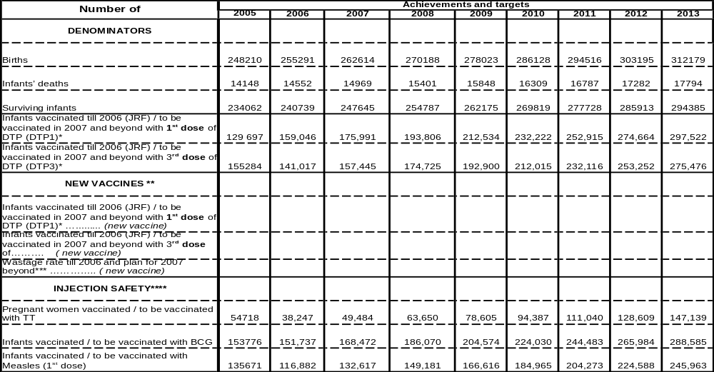

* Indicate actual number of children vaccinated in past years and updated targets (with either DTP alone or combined)
** Use 3 rows (as indicated under the heading NEW VACCINES) for every new vaccine introduced
*** Indicate actual wastage rate obtained in past years
**** Insert any row as necessary

  - Confirmed/Revised request for new vaccine (to be shared with UNICEF Supply Division)
for 2008

In case you are changing the presentation of the vaccine, or increasing your request; please indicate below if UNICEF Supply Division has assured the availability of the new quantity/presentation of supply.

Please provide the XL sheet for calculating vaccine request duly completed and summarize in table 6 below. For calculations, please use same targets as in table 5.

Table 6. Estimated number of doses of …… vaccine. (Please provide additional tables for additional vaccines and number them 6a, 6b, 6c etc)

Vaccine : | 2008 | 2009 | 2010
Total doses required
Doses to be funded by GAVI
Doses to be funded by country
Country co-pay in US$/dose*
Total co-pay
*As per GAVI co-financing policy, country grouping and order of vaccine introduction

Remarks

- Phasing: Please adjust estimates of target number of children to receive new vaccines, if a phased introduction is intended. If targets for hep B3 and Hib3 differ from DTP3, explanation of the difference should be provided
- Wastage of vaccines: Countries are expected to plan for a maximum of 50% wastage rate for a lyophilized vaccine in 10 or 20-dose vial; 25% for a liquid vaccine in a10 or 20-dose vial; 10% for any vaccine (either liquid or lyophilized) in a 2-dose vial, 5% for any vaccine in 1 dose vial liquid.
- Buffer stock: The buffer stock is recalculated every year as 25% the current vaccine requirement
- Anticipated vaccines in stock at start of year 2008: It is calculated by counting the current balance of vaccines in stock, including the balance of buffer stock. Write zero if all vaccines supplied for the current year (including the buffer stock) are expected to be consumed before the start of next year. Countries with very low or no vaccines in stock must provide an explanation of the use of the vaccines.
- AD syringes: A wastage factor of 1.11 is applied to the total number of vaccine doses requested from the Fund, excluding the wastage of vaccines.
- Reconstitution syringes: it applies only for lyophilized vaccines. Write zero for other vaccines.
- Safety boxes: A multiplying factor of 1.11 is applied to safety boxes to cater for areas where one box will be used for less than 100 syringes

Table 7: Wastage rates and factors
Vaccine wastage rate | 5% | 10% | 15% | 20% | 25% | 30% | 35% | 40% | 45% | 50% | 55% | 60%
Equivalent wastage factor | 1.05 | 1.11 | 1.18 | 1.25 | 1.33 | 1.43 | 1.54 | 1.67 | 1.82 | 2.00 | 2.22 | 2.50

3.3 Confirmed/revised request for injection safety support for the year 2008

Table 8: Estimated supplies for safety of vaccination for the next two years with …… (Use one table for each vaccine BCG, DTP, measles and TT, and number them from 8a, 8b, 8c, etc. Please use same targets as in Table 5)

DPT

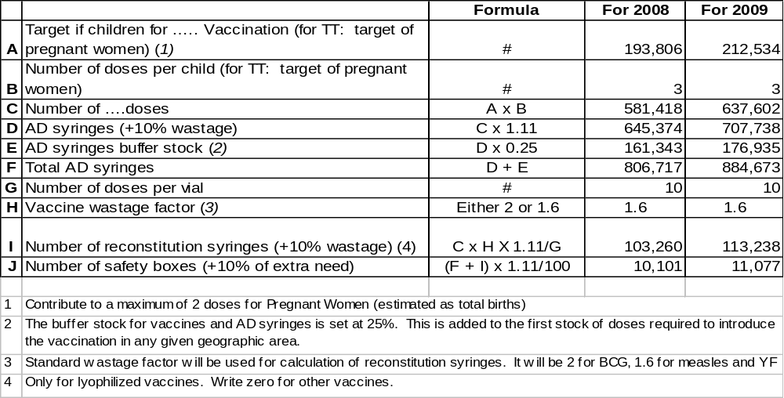

RR

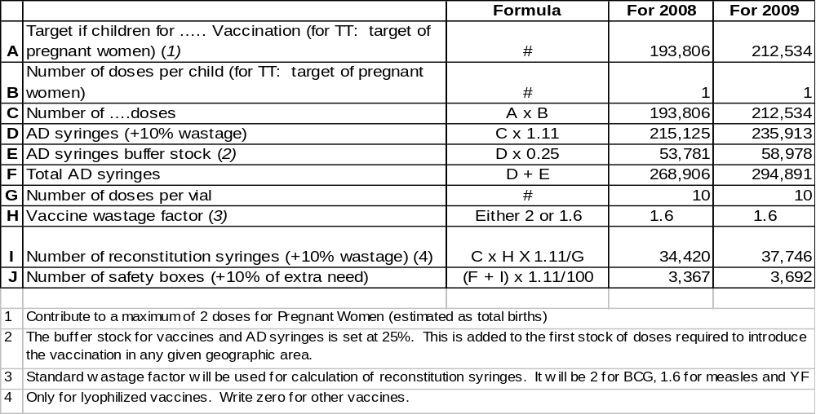

dT

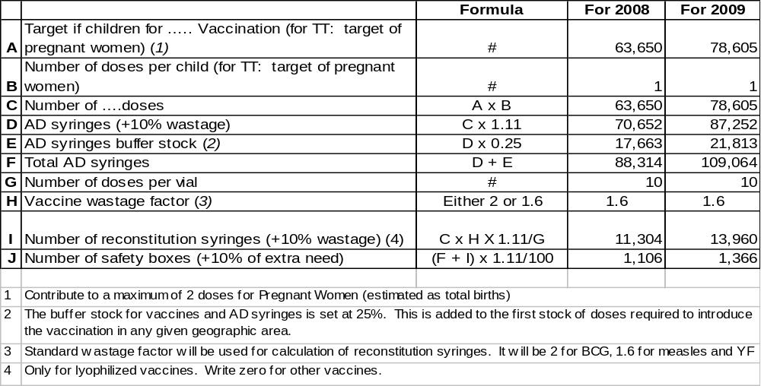

If quantity of current request differs from the GAVI letter of approval, please present the justification for that difference.

4. Health Systems Strengthening (HSS)

This section only needs to be completed by those countries that have received approval for their HSS proposal. This will serve as an inception report in order to enable release of funds for 2008. Countries are therefore asked to report on any activity in 2007.

Health Systems Support started in : _________________

Current Health Systems Support will end in : _____________

Funds received in 2007 : Yes/No
If yes, date received : (dd/mm/yyyy)
If Yes, total amount : US$ ___________
Funds disbursed to date : US$ ___________
Balance of installment left: US$ ___________

Requested amount to be disbursed for 2008 US$ ___________

Are funds on-budget (reflected in the Ministry of Health and Ministry of Finance budget) : Yes/No
If not, why not ? How will it be ensured that funds will be on-budget ? Please provide details.

Please provide a brief narrative on the HSS program that covers the main activities performed, whether funds were disbursed according to the implementation plan, major accomplishments (especially impacts on health service programs, notably the immunization program), problems encountered and solutions found or proposed, and any other salient information that the country would like GAVI to know about. More detailed information on activities such as whether activities were implemented according to the implementation plan can be provided in Table 10.

Are any Civil Society Organizations involved in the implementation of the HSS proposal ? If so, describe their participation?

In case any change in the implementation plan and disbursement schedule as per the proposal is requested, please explain in the section below and justify the change in disbursement request. More detailed breakdown of expenditure can be provided in Table 9.

Please attach minutes of the Health Sector Coordinating Committee meeting(s) in which fund disbursement and request for next tranche were discussed. Kindly attach the latest Health Sector Review Report and audit report of the account HSS funds are being transferred to. This is a requirement for release of funds for 2008.

Table 9. HSS Expenditure in 2007 (Please fill in expenditure on HSS activities and request for 2008. In case there is a change in the 2008 request, please justify in the narrative above)
Area for support | 2007 (Expenditure) | 2007 (Balance) | 2008 (Request)
Activity costs
Objective 1
Activity 1.1
Activity 1.2
Activity 1.3
Activity 1.4
Objective 2
Activity 2.1
Activity 2.2
Activity 2.3
Activity 2.4
Objective 3
Activity 3.1
Activity 3.2
Activity 3.3
Activity 3.4
Support costs
Management costs
M&E support costs
Technical support
TOTAL COSTS

Table 10. HSS Activities in 2007 (Please report on activities conducted in 2007)
Major Activities | 2007
Objective 1:
Activity 1.1:
Activity 1.2:
Activity 1.3:
Activity 1.4:
Objective 2:
Activity 2.1:
Activity 2.2:
Activity 2.3:
Activity 2.4:
Objective 3:
Activity 3.1:
Activity 3.2:
Activity 3.3:
Activity 3.4:

Table 11. Please update baseline indicators. Add other indicators according to the HSS proposal.
Indicator | Data Source | Baseline Value | Source | Date of Baseline | Target | Date for Target
1. National DTP3 coverage (%)
2. Number / % of districts achieving ≥80% DTP3 coverage
3. Under five mortality rate (per 1000)
4.
5.
6.

Please describe whether targets have been met, what kind of problems have occurred in measuring the indicators, how the monitoring process has been strengthened and whether any changes are proposed.

5. Checklist

Checklist of completed form:

Form Requirement: | Completed | Comments
Date of submission | Yes
Reporting Period (consistent with previous calendar year) | Yes
Government signatures | Yes
ICC endorsed | Yes
ISS reported on | Yes
DQA reported on | No | June 2007
Reported on use of 100,000 US$ | No | N/A
Injection Safety Reported on | Yes
Immunisation Financing & Sustainability Reported on (progress against country IF&S indicators) | No | N/A
New Vaccine Request including co-financing completed and XL sheet attached | No | N/A
Revised request for injection safety completed (where applicable) | Yes
HSS reported on | No | N/A
ICC minutes attached to the report | Yes
HSCC minutes, audit report of account for HSS funds and annual health sector evaluation report attached to report | No | N/A

6. Comments

ICC/HSCC comments:

~ End ~

ANNEXE 1 : Couvertures

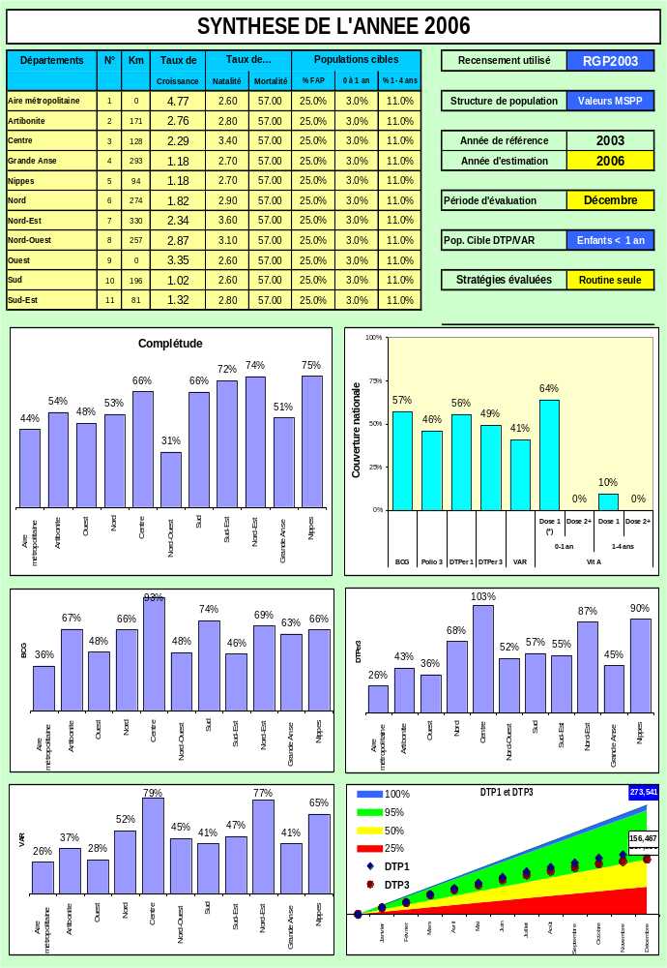

If baseline data is not available indicate whether baseline data collection is planned and when
Important for easy accessing and cross referencing

