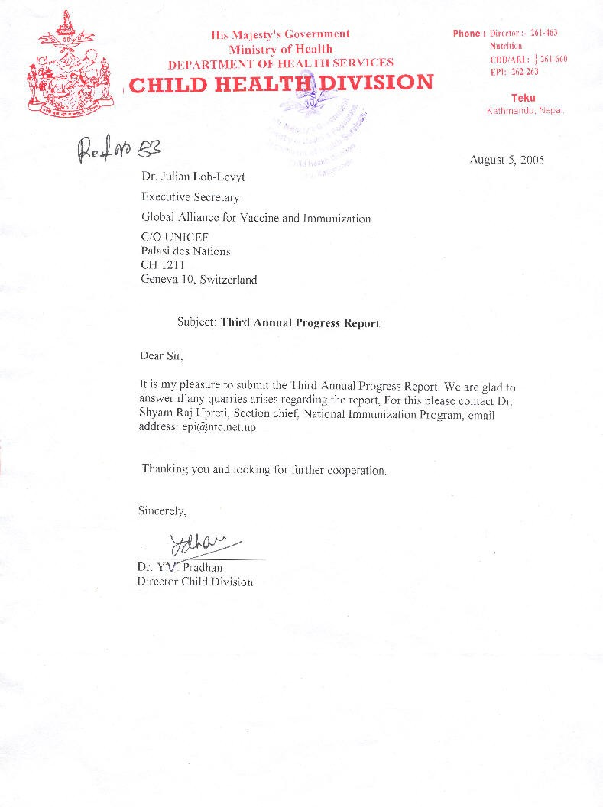

January 2005
Progress Report
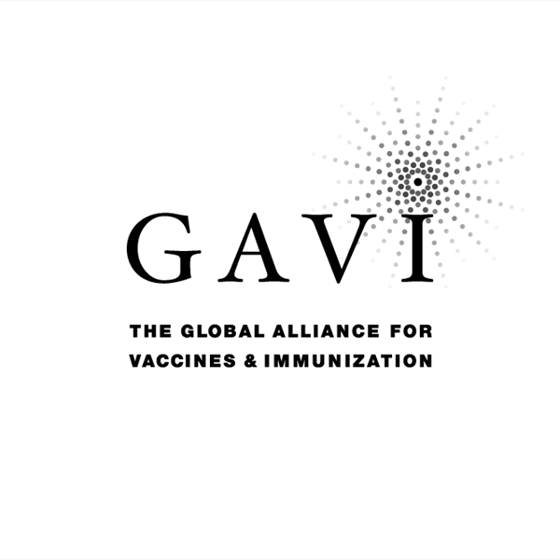
Partnering with The Vaccine Fund

to the
Global Alliance for Vaccines and Immunization (GAVI)
and
The Vaccine Fund

by the Government of
COUNTRY: Nepal
Date of submission: 08, August 2005……………………………

Reporting period: 2004 (14 July, 2004 - 15 July, 2005 ( Information
provided in this report MUST refer to 2004 activities )

( Tick only one ) :
Inception report 
First annual progress report 
Second annual progress report 
Third annual progress report 
Fourth annual progress report 
Fifth annual progress report 

Text boxes supplied in this report are meant only to be used as guides. Please feel free to add text beyond the space provided.
*Unless otherwise specified, documents may be shared with GAVI partners and collaborators

Progress Report Form: Table of Contents

Report on progress made during 2004
  - Immunization Services Support (ISS)
1.1.1 Management of ISS Funds
Use of Immunization Services Support
1.1.3 Immunization Data Quality Audit
  - GAVI/Vaccine Fund New and Under-used Vaccines
1.2.1 Receipt of new and under-used vaccines
1.2.2 Major activities
    - Use if GAVI/The Vaccine Fund financial support (US$100,000) for introduction of the new vaccine
1.3 Injection Safety
    - Receipt of injection safety support
    - Progress of transition plan for safe injections and safe management of sharps waste
    - Statement on use of GAVI/The Vaccine Fund injection safety support (if received in the form of a cash contribution)

2. Financial Sustainability

3. Request for new and under-used vaccine for 2006
  - Up-dated immunization targets
  - Confirmed/revised request for new vaccine (to be shared with UNICEF Supply Division) for year…
  - Confirmed/revised request for injection safety support for the year…

- Please report on progress since submission of the last Progress Report based on the indicators
selected by your country in the proposal for GAVI/VF support

5. Checklist

6. Comments

7. Signatures

1. Report on progress made during 2004

To be filled in by the country for each type of support received from GAVI/The Vaccine Fund.

Immunization Services Support (ISS)

1.1.1 Management of ISS Funds

Please describe the mechanism for management of ISS funds, including the role of the Inter-Agency Co-ordinating Committee (ICC).
Please report on any problems that have been encountered involving the use of those funds, such as delay in availability for programme use.

ISS fund is deposited in a government account and is governed by government financial rules and regulations .Immunization activities funded under the ISS are proposed by the Child Health Division . These activities are made in consultation with the ICC and final approved is done by parliament Access to the funds requires substantial formalities and, once approved, money not be diverted to any other activities The Auditor General does expenditure audit.
Use of ISS fund must follow government guidelines. Per diem and training allowances are thought inadequate by staffs. Supervisors, for example are often reluctant to make field visits.

1.1.2 Use of Immunization Services Support

In 2004, the following major areas of activities have been funded with the GAVI/Vaccine Fund Immunization Services Support contribution.

Funds received during 2004 1. Third tranche ISS fund of US$ 705,000 was received in 2004
2. First tranche Reward Money of US$ 574,550 was received in 2005

Remaining funds (carry over) from 2003 Unspent (carry over) money from the previous Fiscal Year will be known only after receiving audit report from all the 75 districts. This unspent money will only be used in the next FY.

Table 1: Use of funds during 2004

Area of Immunization Services Support | Total amount in US $ | AMOUNT OF FUNDS
Area of Immunization Services Support | Total amount in US $ | PUBLIC SECTOR |  |  | PRIVATE SECTOR & Other
Area of Immunization Services Support | Total amount in US $ | Central | Region/State/Province | District | PRIVATE SECTOR & Other
Vaccines
Injection supplies
Personnel | 42,867 | 42,867
Transportation
Maintenance and overheads | 28,571 | 28,571
Training  CCA training  District Micro planning | 37,141  85,714 | 37,141 |  | 85,714
IEC / social mobilization | 14,286 | 14,286
Outreach
Supervision  Regional review meeting  DDC review meeting  District review meeting | 28,571  7,943  74,286 | 7,943 | 28,571 | 74,286
Monitoring and evaluation  Data Quality Self Assessment | 8,571 | 8,571
Epidemiological surveillance
Vehicles
Cold chain equipment
Other  1) Computers and Printers  2) Printing Guidelines and Training manuals  3) Fuel& electricity  (specify) | 42,857  7,143  10,714 | 42,857  7,143 |  | 10,714
Total: | 388,664 | 189,379 | 28,571 | 170,714
Remaining funds for next year:  a) Unspent amount from last FY (unspent ISS fund and first tranche Reward Money)  b)Second tranche Reward Money due | 1,081,110  574,500

*If no information is available because of block grants, please indicate under ‘other’.

Please attach the minutes of the ICC meeting(s) when the allocation of funds was discussed

Please report on major activities conducted to strengthen immunization, as well as, problems encountered in relation to your multi-year plan.

Major Activities:
- Strengthening NIP and introducing new vaccine:
  - Orientation on AEFI was completed during the National Measles campaign in all the 75 districts and training was also conducted for 31 sentinel sites
  - Training on vaccine management and cold chain equipment maintenance was provided to 80 Cold Chain Assistants
  - Training on Hep B introduction was given to 3010 Vaccinators from 32 districts
  - Micro planning was conducted in 32 districts with the involvement of 4802 Health Unit In charges, Vaccinators and district supervisors;
  - In 32 districts Mid Level Managers training was conducted fro 96 managers.

- Polio Eradication Initiatives
  - Nepal has been able to maintain zero cases of polio since November 2000.
  - Responsive mop-up as a result of imported Indian case was conducted in 4 districts in the Terai
  - Sub-national Immunization Days was conducted in 17 bordering districts with Utter Pradesh and Bihar (India)
  - Cross boarder meeting (with India) in immunization activities focusing on Polio issues conducted and carried recommendations done in the meeting

- Surveillance:
  - JE Surveillance was initiated through integrated surveillance of AFP, Measles and NT
  - Community based surveillance initiated in a 4 districts
  - National Public Health Laboratory was strengthened to support JE and Measles surveillance
- Quality of Data:
  - To carry out Data Quality Self Assessment, a guideline was adapted developed in Nepali, distributed to 10 districts and 2 districts conducted DQAS
  - Initiation of district Data analysis on coverage and drop out to categorise and prioritize for appropriate action and support
- Financial Sustainability:
  - FSP was developed by MoH&P, endorsed by MoF, & ICC and submitted to GAVI Board on Feb 25, 2005
- Multi-year plan of action (2005/2006-2010/2011):
  - Multi-year plan of action is being revised based on the FSP.
- National Measles Campaign
  - Campaign conducted in three phases:
    - First Phase: 35 Districts (Sept. 2004)
    - Second Phase: 33 districts (Jan. 2005)
    - Third Phase: 7 districts (April 2005)
  - Target age group: Children between 9 months - 14 years
  - Total target population: 9,423,866
  - One dose of OPV was provided to children under five
  - Cost of Measles Campaign: US$ 4.54 million from CDC through UNICEF and WHO and. US$ 135,000 by the government
  - Total coverage was >100% i.e. 9,839,723children immunized
Problems encountered:
- Releasing ISS Funds:
  - The process of releasing ISS find is lengthy and time consuming. Therefore, it could not be released to the districts on time.
- Utilization of ISS Funds:
  - HMG per diem and training allowances is extremely low hence dampening the motivation of health workers

Immunization Data Quality Audit (DQA) (If it has been implemented in your country)

Has a plan of action to improve the reporting system based on the recommendations from the DQA been prepared?
If yes, please attach the plan.

YES NO
√

If yes, please report on the degree of its implementation.

Information backup system improvement:
- 33 computers were distributed to the districts
- Software for data analysis was provided to all 75 districts

Supervision and Monitoring:
- Integrated supervision by CHD, WHO, UNICEF
- Review of the EPI data and quarterly feedback to the districts were carried out

Please attach the minutes of the ICC meeting where the plan of action for the DQA was discussed and endorsed by the ICC.

Please report on studies conducted regarding EPI issues during 2004 (for example, coverage surveys).

No specific study or coverage survey was conducted, however the “Data Quality Self-Assessment" guideline was adapted to districts and are encouraged to conduct the assessment. Two districts have already started the process.

GAVI/Vaccine Fund New & Under-used Vaccines Support

1.2.1 Receipt of new and under-used vaccines during 2004

Start of vaccinations with the new and under-used vaccine: November 11, 2002

Please report on receipt of vaccines provided by GAVI/VF, including problems encountered.

Hepatitis B and DPT-HepB vaccine received in 2004/2005 FY
Vaccine/Devices | Delivery Date | Quantity in doses.
Hep B (10 dose vial) | 30-Jun | 625,900
DTP-Hep B (10 dose vial) | May-05 | 870,000

Due to some technical error while preparing the annual budget, in the previous and current fiscal year, districts level training and micro planning were delayed. This also resulted in delayed introduction of HepB in targeted districts. HepB introduction has been completed in all 75 districts of the country.

1.2.2 Major activities

Please outline major activities that have been or will be undertaken, in relation to, introduction, phasing-in, service strengthening, etc. and report on problems encountered.

- Strengthening Routine Immunization Program:
  - In line with GIVS and FSP, the multiyear plan of action is under revision, which gives vision and strategy for the future.
  - Microplanning will be conducted to ensure reaching the un-reached and increasing the coverage universally at VDC level.
  - MLM training will be continued for managers of poorly performing districts.
  - Regional and district review on Immunization will be continued
  - Supportive supervision and monitoring will be continued and strengthened
  - Vaccinator refresher trainings will be continued
  - High importance will be given to data management and feedback system.

- Introduction of Tetravalent (DPT-HepB) vaccine in routine immunization:
  - 24 districts of Mid Western Development Region and Far Western Development Region has introduced Tetravalent from July 2005 and the remaining districts continue HepB monovalent and from February 2006 will introduce tetravalent DPT-HepB.

Problems:
- Shortage of DPT vaccine due to procurement delays, was resolved with support and coordination among partners
  - Some problems were observed in transportation of vaccines, other logistics and movement of supervisors due to ongoing conflict.

1.2.3 Use of GAVI/The Vaccine Fund financial support (US$100,000) for the introduction of the new vaccine

Please report on the proportion of 100,000 US$ used, activities undertaken, and problems encountered such as delay in availability of funds for programme use.

No new fund was available during the reporting period.

Injection Safety

1.3.1 Receipt of injection safety support

Please report on receipt of injection safety support provided by GAVI/VF, including problems encountered

Nepal received the following lots of AD syringes, reconstitution syringes and safety boxes in 2004 and 2005:
Vaccine/Devices | Delivery Date |  | Quantity in pieces.
BCG Syringes (AD) | 25-Mar-04 |  | 831,000
BCG Syringes (AD)* | 19-Oct-04 |  | 125,200
AD Syringes | 24-Jan-04 |  | 5,006,200
AD Syringes* | 19-Oct-04 |  | 504,000
Reconstitution Syringes 2.0 ml (BCG) | 23-Jan-04 |  | 83,100
Reconstitution Syringes 5.0 ml (Measles) | 23-Jan-04 |  | 113,100
Safety Boxes | 18-Feb-04 |  | 66,975
Safety Boxes* | 19-Oct-04 |  | 6,975
BCG Syringes (AD) |  | 05-Apr-05 |  | 258,900
AD Syringes |  | 16-Apr-05 |  | 751,200
Reconstitution Syringes 2.0 ml (BCG) |  | 05-Apr-05 |  | 25,900
Reconstitution Syringes 5.0 ml (Measles) |  | 05-Apr-05 |  | 38,800
Safety Boxes |  | 14-Apr-05 |  | 11,950

Progress of transition plan for safe injections and safe management of sharps waste

Please report problems encountered during the implementation of the transitional plan for safe injection and sharp waste

- Nepal has fully transitioned to ADS in immunisation programme.
- Used syringes are collected in safety boxes which are burned and buried in properly dug pit at health facilities.
- low cost incinerators are encouraged to build at Health facilities
- No remarkable problems faced.

Please report on the progress based on the indicators chosen by your country in the proposal for GAVI/VF support.

Indicators | Targets | Achievements | Constraints | Updated targets
Numbers of districts with HepB introduction in routine immunization  Number of districts using ADS for all injectiable antigens in routine immunization  Number of trained Health Workers on use of safe injection practice & wastage disposable (use of Safety Boxes) | HepB will be introduced in routine immunization in 35 districts  All 75 districts will use ADS for all injectiable antigens in routine immunization  All Health Workers (Vaccinators) | 100%  100%  100% | Few districts introduced HepB vaccine in the routine immunization in later part of year due to late orientation of health staff  In Municipalities, burning and burying of filled boxes was found difficult. So some of the clinics are using locally made incinerators wherever available.

1.3.3 Statement on use of GAVI/The Vaccine Fund injection safety support (if received in the form of a cash contribution)

The following major areas of activities have been funded (specify the amount) with the GAVI/The Vaccine Fund injection safety support in the past year:

Not applicable

2. Financial sustainability

Inception Report: Outline timetable and process for the development of a financial sustainability plan . Describe assistance that may be needed for developing a financial sustainability plan.

First Annual Progress Report: Submit completed financial sustainability plan by given deadline. Describe major strategies for improving financial sustainability.
FSP was developed by MoH&P, endorsed by MoF and ICC members, and submitted to GAVI board on Feb 25, 2005

Subsequent Progress Reports: According to current GAVI rules, support for new and under-used vaccines is covering the total quantity required to meet country targets (assumed to be equal to DTP3 targets) over a five year period (100% x 5 years = 500%). If the requested amount of new vaccines does not target the full country in a given year (for example, a phasing in of 25%), the country is allowed to request the remaining (in that same example: 75%) in a later year. In an attempt to help countries find sources of funding in order to attain financial sustainability by slowly phasing out GAVI/VF support, they are encouraged to begin contributing a portion of the vaccine quantity required. Therefore, GAVI/VF support can be spread out over a maximum of ten years after the initial approval, but will not exceed the 500% limit (see figure 4 in the GAVI Handbook for further clarification). In table 2.1, specify the annual proportion of five year GAVI/VF support for new vaccines that is planned to be spread-out over a maximum of ten years and co-funded with other sources. Please add the three rows (Proportion funded by GAVI/VF (%), Proportion funded by the Government and other sources (%), Total funding for …………. (new vaccine)) for each new vaccine.

Table 2.1: Sources (planned) of financing of new vaccine DPT-HepB (specify)
Proportion of vaccines supported by * | Annual proportion of vaccines
Proportion of vaccines supported by * | 2002..** | 2003.. | 2004. | 2005.. | 2006.. | 2007.. | 2008. | 2089 | 2010. | 2011.
A: Proportion funded by GAVI/VF (%)*** | 100% | 100% | 100% | 100% | 100% | 75% | 16% | 0 | 0 | 0
0 B: Proportion funded by the Government and other sources (%) | 0 | 0 | 0 | 0 | 0 | 25% | 84% | 100% | 100% | 100%
C: Total funding for …………. (new vaccine) | 255,454 | 526,796 | 729,769 | 1,579,011 | 3,515,210 | 3,594,299 | 3,757,862 | 3,842,496 | 3,928,881 | 4,017,271

* Percentage of DTP3 coverage (or measles coverage in case of Yellow Fever) that is target for vaccination with a new and under-used vaccine.

** The first year should be the year of GAVI/VF new vaccine introduction
*** Row A should total 500% at the end of GAVI/VF support
NB: Country will apply for GAVI II on 2006

In table 2.2 below, describe progress made against major financial sustainability strategies and corresponding indicators.

Table 2.2: Progress against major financial sustainability strategies and corresponding indicators
Note: Nepal submitted FSP to GAVI board on 25 Feb 2005, and is closely observing against major financial sustainability strategies and corresponding indicators
Financial Sustainability Strategy | Specific Actions Taken Towards Achieving Strategy | Progress Achieved | Problems Encountered | Baseline Value of Progress Indicator | Current Value of Progress Indicator | Proposed Changes To Financial Sustainability Strategy

3. Request for new and under-used vaccines for year 2006

Section 3 is related to the request for new and under used vaccines and injection safety for 2006.

Up-dated immunization targets

Confirm/update basic data approved with country application: figures are expected to be consistent with those reported in the WHO/UNICEF Joint
Reporting Forms. Any changes and/or discrepancies MUST be justified in the space provided (page 12). Targets for future years MUST be provided.
Table 3 : Update of immunization achievements and annual targets
Number of | Achievements and targets
Number of | 2003/04 | 2004/05 | 2005/06 | 2006/07 | 2007/08 |  | 2008/09 |  | 2009/010 | 2010/011 |  | 2011/012
DENOMINATORS
Births | 831,864 | 850,747 | 870,057 | 889,810 | 910,008 |  | 930,666 |  | 951,792 | 973,398 |  | 995,494
Infants’ deaths | 53,406 | 54,618 | 55,858 | 57,126 | 58,423 |  | 59,749 |  | 61,105 | 62,492 |  | 63,911
Surviving infants | 778,458 | 796,129 | 814,199 | 832,684 | 851,586 |  | 870,917 |  | 890,687 | 910,906 |  | 931,583
Infants vaccinated in 2004 (JRF) / to be vaccinated in 2005 and beyond with 1st dose of DTP (DTP1)* | 688,763 | 688,781 | 536,612
Infants vaccinated 2004 (JRF) / to be vaccinated in 2005 and beyond with 3rd dose of DTP (DTP3)* | 652,640 | 657,811 | 509,781
NEW VACCINES **
Infants vaccinated 2004 (JRF) / to be vaccinated in 2005 and beyond with 1st dose of -HepB* …......... (new vaccine) | 174,872 | 215,505 | 536,612
Infants vaccinated 2004 (JRF) / to be vaccinated in 2005 and beyond with 3rd dose of HepB ( new vaccine) | 125,275 | 196,596  ** | 509,781
Infants vaccinated 2004 (JRF) / to be vaccinated in 2005 and beyond with 1st dose of DTP-HepB* …......... (new vaccine) |  |  | 193,119 | 765,200 | 790,929 |  | 817,413 |  | 844,697 | 863,702 |  | 883,135
Infants vaccinated 2004 (JRF) / to be vaccinated in 2005 and beyond with 3rd dose of DPT-HepB ( new vaccine) |  |  | 183,463 | 726940 | 751383 |  | 776542 |  | 802462 | 820517 |  | 838978
Wastage rate in 2004 and plan for 2005 beyond*** ………….. ( new vaccine) | *** | 25% | 21% | 15% | 15% |  | 15% |  | 15% | 15% |  | 15%
INJECTION SAFETY****
Pregnant women vaccinated in 2004 (JRF) / to be vaccinated in 2005 and beyond with TT2 | 685,924 | 756,832 | 943,953 | 965,286 | 987,101 | 1,009,410 |  | 1,032,223 |  |  | 1,055,551 |  | 1,079,406
Infants vaccinated in 2004 (JRF) / to be vaccinated in 2005 and beyond with BCG * | 734,365 | 701,853 | 814,199 | 832,684 | 851,586 | 870,917 |  | 890,687 |  |  | 910,906 |  | 931,583
Infants vaccinated in 2004 (JRF) / to be vaccinated in 2005 and beyond with Measles * | 606,834 | 622,613 | 814,199 | 832,684 | 851,586 | 870,917 |  | 890,687 |  |  | 910,906 |  | 931,583
* Indicate actual number of children vaccinated in 2004 and updated targets (with either DTP alone or combined)
** Use 3 rows (as indicated under the heading NEW VACCINES) for every new vaccine introduced
*** Indicate actual wastage rate obtained in past years
**** Insert any row as necessary
** Introduction of HepB in routine immunization was done in 17 districts in FY 2002/2003. In the FY 2003/2004 more 26 districts introduced the HepB vaccine , the date above is of those districts
Fiscal Year in Nepal is July 15 to July 14 (Example FY 2004 is from July 15 2003 to July 14 2004)
For Pregnant women, TT intensification program will be conducted in the districts
For New vaccine DPT-HepB3 5% dropout is subtracted
For Measles and BCG The target population is from FSP projection sheet

Please provide justification on changes to baseline, targets, wastage rate, vaccine presentation, etc. from the previously approved plan, and on reported figures which differ from those reported in the WHO/UNICEF Joint Reporting Form in the space provided below.

Number of |  | Targets
 |  | 2003/04 | 2004/05 | 2005/06 | 2006/07 | 2007/08 | 2008/09 | 2009/010 | 2010/011 | 2011/012
DENOMINATORS
Births
Infants’ deaths
Surviving infants
 | Fiscal Year in Nepal is July 15 to July 14 (Example FY 2004 is from July 15 2003 to July 14 2004)
3.2 Availability of revised request for new vaccine (to be shared with UNICEF Supply Division) for 2006

In case you are changing the presentation of the vaccine, or increasing your request; please indicate below if UNICEF Supply Division has assured the availability of the new quantity/presentation of supply.
CHD has already submitted the request for DPT-HepB supply, and CHD has received the supply plan from UNICEF as per requested by CHD
- Request Plan for Shipment of tetravalent DPT-HepB Vaccine for 2006
- Total tetravalent Vaccine required till Dec 2006 is 290,093 Vials
- Tetravalent vaccine received to date is 87000 Vials
- Further tetravalent vaccine needed up to 2006: 203093 Vials (290093-87000)
Shipment Plan
S.No | Shipment Date | Quantity of Tetravalent vaccine. | Remarks
1 | Last week of December 2005 | 70000 Vials
2 | Last week of March 2006 | 70000 Vials
3 | August 2006 | 63000 Vials
Total Vaccine |  | 203000 Vials

Table 4: Estimated number of doses of DPT-HepB vaccine (specify for one presentation only): Please repeat this table for any other vaccine presentation requested from
GAVI/The Vaccine Fund

*Please report the same figure as in table 3.
Table 5: Wastage rates and factors
Vaccine wastage rate | 5% | 10% | 15% | 20% | 25% | 30% | 35% | 40% | 45% | 50% | 55% | 60%
Equivalent wastage factor | 1.05 | 1.11 | 1.18 | 1.25 | 1.33 | 1.43 | 1.54 | 1.67 | 1.82 | 2.00 | 2.22 | 2.50

Remarks
- Phasing: Please adjust estimates of target number of children to receive
new vaccines, if a phased introduction is intended. If targets for hep B3 and Hib3
differ from DTP3, explanation of the difference
should be provided
- Wastage of vaccines: Countries are expected to plan for a maximum of:
50% wastage rate for a lyophilized vaccine in 10 or 20-dose vial; 25% for a liquid
vaccine in a10 or 20-dose vial; 10% for any vaccine (either liquid or lyophilized)
in 1 or 2-dose vial.
- Buffer stock: The buffer stock is recalculated every year as 25% the current
vaccine requirement
- Anticipated vaccines in stock at start of year 2006: It is calculated by
counting the current balance of vaccines in stock, including the balance of buffer
stock. Write zero if all vaccines supplied for the current year (including the
buffer stock) are expected to be consumed before the start of next year. Countries
with very low or no vaccines in stock must provide an explanation of the use of
the vaccines.
- AD syringes: A wastage factor of 1.11 is applied to the total number
of vaccine doses requested from the Fund, excluding the wastage of vaccines.
- Reconstitution syringes: it applies only for lyophilized vaccines. Write zero
for other vaccines.
- Safety boxes: A multiplying factor of 1.11 is applied to safety boxes to cater
for areas where one box will be used for less than 100 syringes

3.3 Confirmed/revised request for injection safety support for the years 2006 -2007

Table 6: Estimated supplies for safety of vaccination for the next two years with TT (Use one table for each vaccine BCG, DTP, measles and TT, and number them from 4 to 8)
Note: Target population is based on Table 3 , for TT BCG and Measles

 |  | Formula | For year 2006 (2006/07) | For year 2007 (2007/08)
A | Target for TT pregnant women | # | 943953 | 965286
B | Number of doses per Pregnant woman | # | 2 | 2
C | Number of TT doses | A x B | 1887906 | 1930572
D | AD syringes (+10% wastage) | C x 1.11 | 2095576 | 2142935
E | AD syringes buffer stock 2 | D x 0.25
F | Total AD syringes | D + E | 2095576 | 2142935
G | Number of doses per vial | # | 10 | 10
H | Vaccine wastage factor 4 | Either 2 or 1.6 | 1.6 | 1.6
I | Number of reconstitution syringes (+10% wastage) 3 | C x H X 1.11/G | 0 | 0
J | Number of safety boxes (+10% of extra need) | (F + I) x 1.11/100 | 23261 | 23787

Target for TT pregnant women is from FSP projection sheet with 100% as districts are planned intensified TT program to increase coverage

Table 6.1 : Estimated supplies for safety of vaccination for the next two years with BCG

Table 6.2 : Estimated supplies for safety of vaccination for the next two years with Measles

If quantity of current request differs from the GAVI letter of approval, please present the justification for that difference.

4. Please report on progress since submission of the last Progress Report based on the indicators selected by your country in the proposal for GAVI/VF support
According to Multi Year Plan of Action Nepal had set the following indicators and targets
Indicators | Targets | Achievements | Constraints | Updated targets
1. Number of districts with coverage more than 80% or above for all antigen  2. Number of wild poliovirus cases  3. Number of districts with NT cases <1/1000 LB.  4. Number of districts with routine measles coverage more than 90%  5. Number of districts with HepB introduced into routine immunization | 1. All 75 districts will have coverage of at least 80% for all routine antigens  2. zero cases of wild poliovirus  3. Number of districts with NT cases <1/1000 LB.  4. 35 districts will have routine measles coverage more than 90%  5. 35 additional districts will have HepB introduced into their routine immunization | 1. Only 11 districts have coverage of 80% for all routine antigens ( BCG, DPT, OPV & measles)  2. zero cases  3. 100%  4. Only 7 districts have measles coverage > 90%  5. 100% | 1. Availability of staff in remote places, timely supply of vaccine and other logistics, inadequate supervision and monitoring and limited movement of staff due to conflict were the major constraints in achieving the targets.  2. Open border with UP & Bihar state of India makes Nepal vulnerable of importation of wild poliovirus  3. Validation for MNT elimination will take place in Nov. 2005  4. Explained in indicator number 1.  5. Few districts HepB vaccination started later part of the year due to delayed orientation of health staff | 1. Achieve and sustain routine coverage of 90% in all 75 districts for all antigen by FY 2010/11.

Checklist

Checklist of completed form:

Form Requirement: | Completed | Comments
Date of submission | 08,08,005
Reporting Period (consistent with previous calendar year) | Completed
Table 1 filled-in | Completed
DQA reported on | Completed
Reported on use of 100,000 US$ | Completed
Injection Safety Reported on | Completed
FSP Reported on (progress against country FSP indicators) | Completed
Table 2 filled-in | Completed
New Vaccine Request completed | Completed
Revised request for injection safety completed (where applicable) | Completed
ICC minutes attached to the report
Government signatures | Completed
ICC endorsed | Completed

6. Comments

ICC/RWG comments:

